The complete RHIS curriculum is available here: https://www.measureevaluation.org/our-work/routine-health-information-systems/rhis-curriculum
Ethiopia Case Study:
Community Health Information System in Action in the Southern Nations, Nationalities, and Peoples’ Region (SNPPR), Ethiopia

Instructions for Trainers

The ultimate goal of the routine health information system (RHIS) is that the data produced are used for decision making at various levels of the health system.
- Patient/client-level and community-management level: Focus on improving quality of care, including continuity of care, as well as on behavioral change
- Facility-management level: Focus on service delivery coverage and quality of care
- District-management level: Focus on management of health services and resources as well as on service-delivery coverage and quality
- Regional and national levels: Focus on health planning, program management, and policy development
The focus of this case study is the community-management level, and how community health workers, facility-based care providers, and district health managers can use data produced by the community health information system to improve community health services and the health of the population. This case study describes how female “health extension workers” in a health post in Ethiopia use the family folders and the tickler file system to improve the health of households and individuals in the southern region (SNNPR) of Ethiopia.
Goal
The aim is for participants to learn how data are to be used for patient/client and community management in a real-life situation in a health post in Ethiopia.
Method
Group discussion following reading of the case study.
Description of Session
The session takes one hour and consists of a lecture/slide presentation (15 minutes), a group work session (30 minutes), and a plenary session to report out (15 minutes).
First, the facilitator will present the context of the case study and briefly explain the structure of the community health services in Ethiopia and how the community health information system (CHIS) has been organized.
Participants will work in groups of 3–5. They will first read the case study for 5 minutes and then spend 25 minutes discussing each of the following topics:

- Does the CHIS respond to the data needs of community health services in Ethiopia?
- The CHIS is based on the Health Extension Program’s services offered by the health extension workers. This close link between the “business offered” and the “data collected” is very important for the relevance of the data and its use for decision making.
- List potential uses of CHIS data for improving community health services delivery:
- Behavioral change interventions
- Environmental health interventions
- Preventive care in maternal, newborn, and child health (MNCH) and infectious diseases
- Continuity of care for chronic diseases and MNCH care
- Describe how the family folder was implemented in the health program’s catchment area.
- Describe how the tickler file system can help to ensure continuity of care for chronic patients and MNCH clients.
Small groups reconvene in a short plenary session (15 minutes) and report out on the following:
- Contribution by the group for each of the discussion points
- Any problems your team identified in the design of the CHIS in Ethiopia
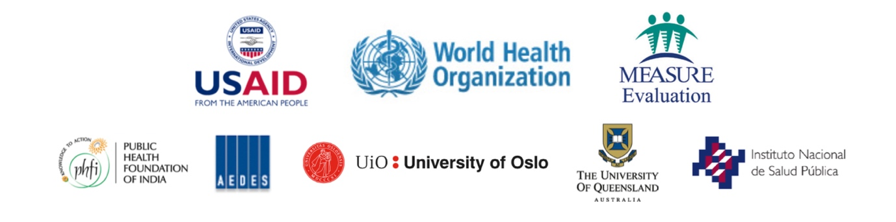
- Available documentation (family folders; individual record cards)

