The complete RHIS curriculum is available here: https://www.measureevaluation.org/our-work/routine-health-information-systems/rhis-curriculum

Ethiopia Case Study 2:
Analysis and Use of Data at the Community Level

The focus of this case study is the use of information generated by the community-based health information system by the community health workers (called health extension workers, or HEWS, in Ethiopia) and other service providers. In this case study, the participants review a chart and a table with raw data on antenatal care visits and contraceptive acceptance at a rural health post in Ethiopia to learn how an HEW can analyze the data generated at the primary service delivery level and use it to decide on actions.

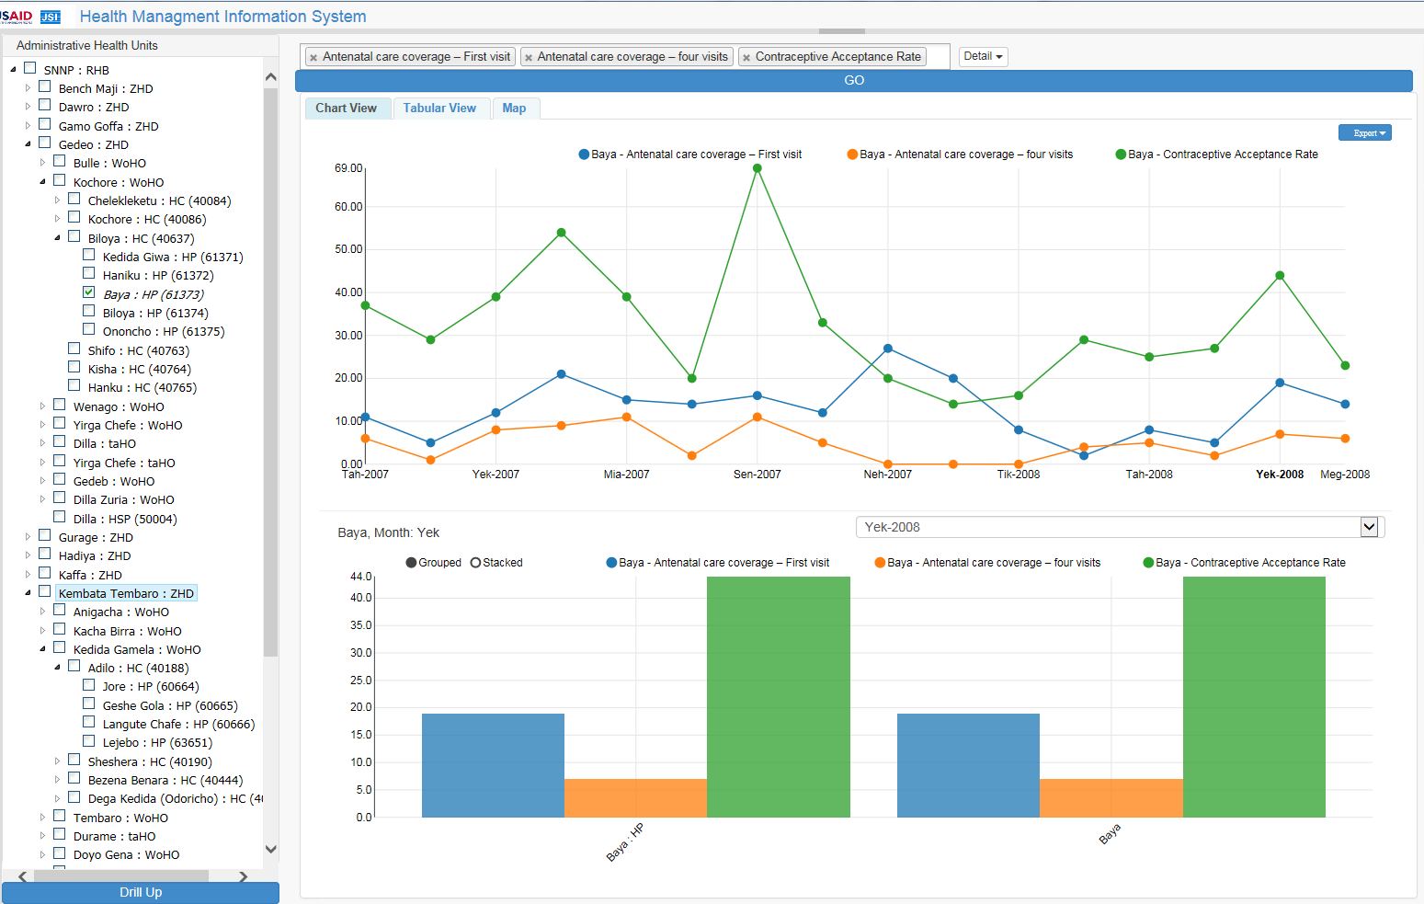
The Health Post Health Service Delivery Performance Data

Ethiopia Month/Yr | ANC: First Visit | ANC: Fourth Visit | Contraceptive Acceptance
Tah 2007 | 11 | 6 | 37
Tir 2007 | 5 | 1 | 29
Yek 2007 | 12 | 8 | 39
Meg 2007 | 21 | 9 | 54
Mia 2007 | 15 | 11 | 39
Gin 2007 | 14 | 2 | 20
Sen 2007 | 16 | 11 | 69
Ham 2007 | 12 | 5 | 33
Neh 2007 | 27 | 0 | 20
Mes 2008 | 20 | 0 | 14
Tik 2008 | 8 | 0 | 16
Hid 2008 | 2 | 4 | 29
Tah 2008 | 8 | 5 | 25
Tir 2008 | 5 | 2 | 27
Yek 2008 | 19 | 7 | 44
Meg 2008 | 14 | 6 | 23

Description of Case
These data are from a rural health post (HP). The HP is served by two HEWs responsible for providing primary healthcare.
- This health post (Baya HP) serves a population of 9,227.
- The estimated percentage of women of reproductive age (WRA) is 23.3 percent.
- The estimated number of pregnancies is 3.46 percent.
- Conversely, the estimated number of nonpregnant WRA is 19.84 percent.

Case Study Questions
- How is this HP performing in terms of maternal health care?
- Why is the HEW comparing the contraceptive acceptance rate with antenatal care data?
- Using the data, what actions can the HEW take?
Additional Questions
- How did you calculate the percentage of contraception acceptance; what denominator did you use (e.g., WRA or nonpregnant WRA)?

- How are the monthly performances of ANC1 and ANC4 calculated in the chart? What denominator is used for monthly performance calculation?

