GEND_GBV Rapid Data Quality Review Tool: In-Person Review

Name of site ___________________________________________________________________ Location ___________________________
Name of implementing partner _______________________________________________________________________________________
Name of person completing this questionnaire ___________________________________________Date __________________________
Title of person completing this questionnaire____________________________________________________________________________
Organization of person completing this questionnaire ____________________________________________________________________
For this assessment, you will need to bring the following:
☐ Definitions of types of gender-based violence (GBV)
☐ PEPFAR MER indicator reference sheets
☐ Minimum package poster
☐ Camera

During the assessment, you will need to review the following documents with the respondent(s).
☐ GBV registers (current register with entries)
☐ GBV-specific data collection forms (if different from above—for example, monthly summary forms)

WELCOME

[Introduction:] I am working with _________ and am here to learn more about documentation and reporting of your site’s gender-based violence (GBV) care for the United States President’s Emergency Plan for AIDS Relief. (You’ve probably heard it referred to by its abbreviation: PEPFAR). I’d like to hear about your site’s successes and challenges in providing and reporting on GBV response services. The information I gather will be used to improve the support PEPFAR gives to your site, as well as to help identify any best practices your site implements that can be shared with other sites.
I am meeting with people who are responsible for completing GBV registers, monthly summary tools, and/or PEPFAR reporting forms. I will be asking you questions using a standard assessment tool.
Your response to all questions is voluntary. We will not be collecting or disclosing the names of clients or beneficiaries or other personally identifiable information about them.
Are you comfortable proceeding with the interview? [Mark: ☐ Yes ☐ No If the participant answers “no,” stop the interview and thank the participant for their time.]
 | Questions |  |  | RESPONSES/NOTES
1. Respondent Information | I’d like to start with a few questions about your current position.
 | 1.1. What is your title/position?
 | 1.2. Please briefly describe your role, if any, with regard to GBV service provision?
 | 1.3. Please briefly describe your role, if any, in documentation of GBV services?
 | Questions | YES | NO | RESPONSES/NOTES
2. Definitions | My next questions are about identifying GBV.
 | 2.1. How does your site define GBV?
 | 2.2. Have you heard about different types of GBV?  If yes, please explain. | ☐ | ☐
 | 2.3. Do you think there is a difference in the way people define GBV for men/boys and women/girls?  [Note: If respondent has trouble defining GBV, please review GBV definition before proceeding.] | ☐ | ☐ | If yes, how is it different?

 | Questions | YES | NO | RESPONSES/NOTES
3. Familiarity with GEND_GBV | In this section I will ask you about your familiarity with the PEPFAR MER GEND_GBV indicator.
 | 3.1. Are you familiar with PEPFAR’s GEND_GBV indicator? | ☐ | ☐ | If no, skip to 4.1.
 | 3.2. How would you explain the indicator?
 | 3.3. Do you have the GEND_GBV indicator reference sheet at your facility? | ☐ | ☐ | Check “Yes” if indicator reference sheet was verified as present.
 | 3.4. Do you have data collection and reporting guidelines at your facility? | ☐ | ☐ | Check “Yes” if data collection and reporting guidelines were verified as present.
 | 3.5. Have you received training on how to calculate the indicator? | ☐ | ☐ | If yes, please describe.
 | 3.6. Do you know what your site’s GEND_GBV targets are? | ☐ | ☐ | If yes, please specify.
 | 3.7. When a client reports more than one type of violence, how do you record “type of violence” in the intake form/register?

 | Questions | YES | NO | RESPONSES/NOTES
4. Services Available | Next we will review the GBV services available here. Please review this poster detailing the minimum package of clinical services. [Note to assessor: Provide a copy or copies of the poster to the respondent(s).]
4.1. What services from the minimum package does your site provide? Complete the questions below for each service. Add additional columns as needed.
 | Rapid HIV testing | Post-exposure prophylaxis (PEP) | Sexually transmitted infection (STI) screening/testing and treatment | Emergency contraceptive (EC) | Counseling (first-line support: LIVES*)
4.2. Does your site offer each of these services? [Y/N]
If no, why?
4.3. Where are the following services provided (e.g., outpatient department, inpatient department, HIV unit/antiretroviral therapy clinic, maternal and child health/family planning unit, antenatal care/prevention of mother-to-child transmission of HIV unit, other)?
4.4. When are these services available (e.g., 24 hours a day, working hours)?
*First-line support is immediate counseling offered to someone who just disclosed violence and/or reported for services. LIVES stands for “Listen, inquire about needs and concerns, validate, enhance safety, and support.” More here: https://www.who.int/reproductivehealth/publications/violence/vaw-clinical-handbook/en/.

 | 4.5. Are any services provided to the partner of the survivor? | YES ☐ | NO ☐ | If yes, what services?
 | 4.6. Are these services recorded in the GBV register? | ☐ | ☐
 | 4.7. Are these services counted as part of GEND_GBV? | ☐ | ☐ | If yes, please explain when/how.
 | 4.8. Is there a gender focal person who oversees GBV responses service? | ☐ | ☐ | If yes, please explain:

 | Questions | YES | NO | RESPONSES/NOTES
5. Referrals | Next I have a few questions for you about referrals to other facilities.
 | 5.1. Are clients coming to your site for GBV services ever referred to outside sites for services?  If no, skip to 6.1.  If yes, Probe for each of the following:  5.1a Rapid HIV tests  5.1b PEP  5.1c EC  5.1d STI screening/testing and treatment  5.1e Other necessary clinical treatment  5.1f Psychosocial counseling  5.1g Other (e.g., police, legal, child protection, shelter, economic strengthening) | ☐ | ☐ | If yes:  5.1a Rapid HIV tests  5.1b PEP  5.1c EC  5.1d STI screening/testing and treatment  5.1e Other necessary clinical treatment  5.1f Psychosocial counseling  5.1g Other (e.g., police, legal, child protection, shelter, economic strengthening)
 | 5.2. If the client is referred for any services in the minimum package, is this person documented as having received the services in the forms/register? | ☐ | ☐
 | 5.3. Is this person counted toward GEND_GBV? | ☐ | ☐

 | Questions | YES |  | NO |  | RESPONSES/NOTES
6. Recording | This next series of questions will help me understand how and when the GBV services your site provides are generally documented in registers, forms, files, etc.
6.1. What forms do clinic staff fill out when a client presents for post-GBV clinical care services? [List each form in a separate column in the table below. Complete the questions below for each form. Add additional columns as needed.]
6.2. List form title. | Title: | Title: | Title: | Title:
6.3. Who fills the register/form out? (List positions and units – e.g., HIV, family planning, etc.)

 | 6.4. How do you ensure everyone is filling out the register/form the same?
 | 6.5. Is there training on how to complete the form/register? |  | ☐ |  | ☐ | If yes, please describe:
 | [Prompt:] At the end of the interview, I would like to review these completed registers/forms.

 | Questions | YES | NO | RESPONSES/NOTES
7. Stockouts | Now I have some questions about medicine management and related data collection.
 | 7.1. Has your site ever experienced a time when one or more of the commodities in the minimum package were stocked out?  If no, skip to 7.4. | ☐ | ☐
 | 7.2. If yes, how does your site record the provision of post-GBV services in registers/forms when commodities in the minimum package are out of stock? For example, if someone came into the clinic as a sexual violence survivor, and you had all the commodities needed for services except PEP, how would you record provision of post-GBV services to that client?
 | 7.3. Would this client be counted toward GEND_GBV? | ☐ | ☐
 | 7.4. Are there other reasons, besides stockouts, that one of the services in the minimum package (rapid HIV tests, PEP, EC, STI tests, and STI treatment) would not be available? | ☐ | ☐ | If yes:  What is the reason?  How is this handled with regard to reporting?

 | Questions | YES | NO | RESPONSES/NOTES
8. Reporting on GEND_GBV | We are also interested to learn how you report on the data that you collect.
 | 8.1. Who is responsible for aggregating data needed to report GEND_GBV? [title/position]
 | 8.2. How do you decide if a client should be counted under GEND_GBV?
 | 8.3. From which forms or registers do you get the data required to report on GEND_GBV?
 | 8.4. Please explain the process of how data are aggregated to obtain GEND_GBV.
 | 8.5. How do you track PEP completion as part of GEND_GBV reporting?
 | 8.6. How often does your site report GEND_GBV data to the implementing partner?
 | 8.7. If the following are not available, is a client counted as having received GBV services as part of the GEND_GBV indicator?  a. Rapid HIV testing  b. PEP  c. STI screening/testing and treatment  d. EC | ☐ | ☐

 | Questions | YES | NO | RESPONSES/NOTES
9. Closing | I now have a few last questions to learn your perspective on challenges and potential improvements related to GBV service monitoring and reporting.
 | 9.1. What do you believe are the main challenges in the monitoring and reporting process for the PEPFAR GEND_GBV indicator?
 | 9.2. Is there anything else you would like to tell me?

CLOSING
Thank you for your time and your responses. Your participation in this assessment has increased my understanding of your site’s GBV service provision and data reporting processes. Based on the information you have provided, we will continue to work to ensure that you have the support, information, and tools you need to provide quality post-violence clinical care services to your community. Once this information has been reviewed we will share our findings with your site. Thank you.

[Note: If respondents indicate that they are not familiar with GEND_GBV during the assessment, you can offer to explain the indicator as well as the minimum service package at this time.]
This tool was produced with the support of the United States Agency for International Development (USAID) under the terms of MEASURE Evaluation cooperative agreement AID-OAA-L-14-00004. MEASURE Evaluation is implemented by the Carolina Population Center, University of North Carolina at Chapel Hill in partnership with ICF International; John Snow, Inc.; Management Sciences for Health; Palladium; and Tulane University. Views expressed are not necessarily those of USAID or the United States government. TL-19-43a

GEND_GBV Rapid Data Quality Review Tool: Document Review Checklist

Name of site ___________________________________________________________________ Location ______________________________
Name of implementing partner __________________________________________________________________________________________
Name of register/form reviewed _________________________________________________________________________________________
Name of person completing this questionnaire ______________________________________ Date __________________________________
Title of person completing this questionnaire ______________________________________________________________________________
Organization of person completing this questionnaire _______________________________________________________________________

The questions in this tool are about the register(s)/form(s) used to record information about clients receiving gender-based violence (GBV) response services.
In addition to completing the questions below, please take photographs of the following:
☐ All registers used to record information for clients receiving GBV response services (take a photo of a blank page).
☐ All forms used to aggregate data for reporting purposes for GBV response services (only photograph blank forms).

Always ask permission prior to taking a photograph, even if just photographing blank documents. Additionally, always take care to cover the names on the records when reviewing and do not record any personally identifiable information. Assure the site staff that no confidential information will be captured or photographed.
Answer the questions below based on the completed register where information about clients receiving GBV services is recorded. If additional registers or forms are used to collect information, complete this checklist again for each of those registers or forms (i.e., a new checklist should be completed for each register/form used to capture information about the provision of GBV response services).

 |  | YES | NO
Are at least 20 records in the GBV register available for review? |  | ☐ | ☐ | If yes, review only those 20 most-recent records.  If no, how many records are available for review during this assessment? ______
Please note who developed this form/register (e.g., government, implementing partner (IP), unknown) _________________________________________
Data collection standard | Record if the data collection form captures the following fields: | YES | NO | If yes, number of times this field is blank in the records reviewed | NOTES
1. Patient characteristics are thoroughly captured by the monitoring system | - Sex of the client | ☐ | ☐
 | - Age of the client  - Captured by recording age at time of visit  - Captured by recording date of birth (DOB)  - Captured by marking/checking/circling an age range (Please note the age ranges in the comments section.) | ☐  ☐  ☐ | ☐  ☐  ☐
 | - Type of violence  Type of violence included:  - Emotional  - Physical  - Sexual  - Other (specify):  - Other (specify):  - Other (specify):  Please note any discrepancies in categories above in comment section (e.g., if physical and emotional violence are reported together on the form), or any instructions about prioritizing a type of violence. | ☐  ☐  ☐  ☐  ☐  ☐ | ☐  ☐  ☐  ☐  ☐  ☐
 | 1.4. Date of presentation at clinic | ☐ | ☐
 | 1.5. For sexual violence, date of last assault, if known | ☐ | ☐
 | 1.6. For sexual violence, time of last assault, if known | ☐ | ☐
Data collection standard | Record if the data collection form captures the following fields: | YES | NO | If yes, number of times this field is blank in the records reviewed | NOTES
2. Availability and provision of the minimum package of services is documented | 2.1. Rapid HIV testing  The site provides rapid HIV tests.  If site provides rapid HIV tests, registers/forms have a way to record:  - Whether or not the client received a rapid HIV test  - Results of the HIV test | ☐  ☐  ☐ | ☐  ☐  ☐ | a.  b.
 | 2.2. Post-exposure prophylaxis (PEP)  The site provides PEP.  If site provides PEP, registers/forms have a way to record:  - Whether or not the client started PEP  - Whether or not the client completed the 28-day course of PEP | ☐  ☐  ☐ | ☐  ☐  ☐ | a.  b.
 | 2.3. Emergency contraception (EC)  The site provides EC.  If site provides EC, registers/forms have a way to record:  - Whether or not the client received EC | ☐  ☐ | ☐  ☐ | a.
 | 2.4. Sexually transmitted infections (STIs)  The site provides screening/testing for STIs.  If site provides STI screening/testing, registers/forms have a way to record:  - Whether or not the client received STI screening/testing  - Whether or not the client received STI treatment | ☐  ☐  ☐ | ☐  ☐  ☐
 | 2.5. Counseling (first-line support: LIVES)  The site provides counseling (first-line support).  If site provides counseling (first-line support), registers/forms have a way to record:  - Whether or not the client received counseling | ☐  ☐ | ☐  ☐ | a.
 |  | YES | NO | If yes, number of times this field is blank in the records reviewed | NOTE
3. Other relevant services | Note whether register/form captures provision and/or referral for each of the following services:
 | 3.1. Longer-term psychosocial support (e.g., peer support groups) | ☐ | ☐
 | 3.2. Legal services | ☐ | ☐
 | 3.3. Police services | ☐ | ☐
 | 3.4. Child protection services | ☐ | ☐
 | 3.5. Economic empowerment | ☐ | ☐
 | 3.6. Other services (please specify) | ☐ | ☐
 | 3.7. Do you track referral completion? If so, how do your track it? | ☐ | ☐
 |  | YES | NO | If yes, number of times this field is blank in the records reviewed. | NOTES
4. Stockouts | 4.1. The form has the ability to capture stockouts of any commodities in the minimum package (rapid HIV test kits, PEP, EC, STI tests, and STI treatment). | ☐ | ☐
 | 4.2 In cases where GBV forms do not document stockouts, there is another mechanism for doing so. (Please specify.) | ☐ | ☐
 | 4.3. If answering “yes” to 4.1 or 4.2, which of these commodities have been out of stock in the past 3 months:  - Rapid HIV tests  - PEP  - EC  - STI tests  - STI treatment medicines |  |  | How many times in the past 3 months?  - ____  - ____  - ____  - ____  - ____

This tool was produced with the support of the United States Agency for International Development (USAID) under the terms of MEASURE Evaluation cooperative agreement AID-OAA-L-14-00004. MEASURE Evaluation is implemented by the Carolina Population Center, University of North Carolina at Chapel Hill in partnership with ICF International; John Snow, Inc.; Management Sciences for Health; Palladium; and Tulane University. Views expressed are not necessarily those of USAID or the United States government. TL-19-43b

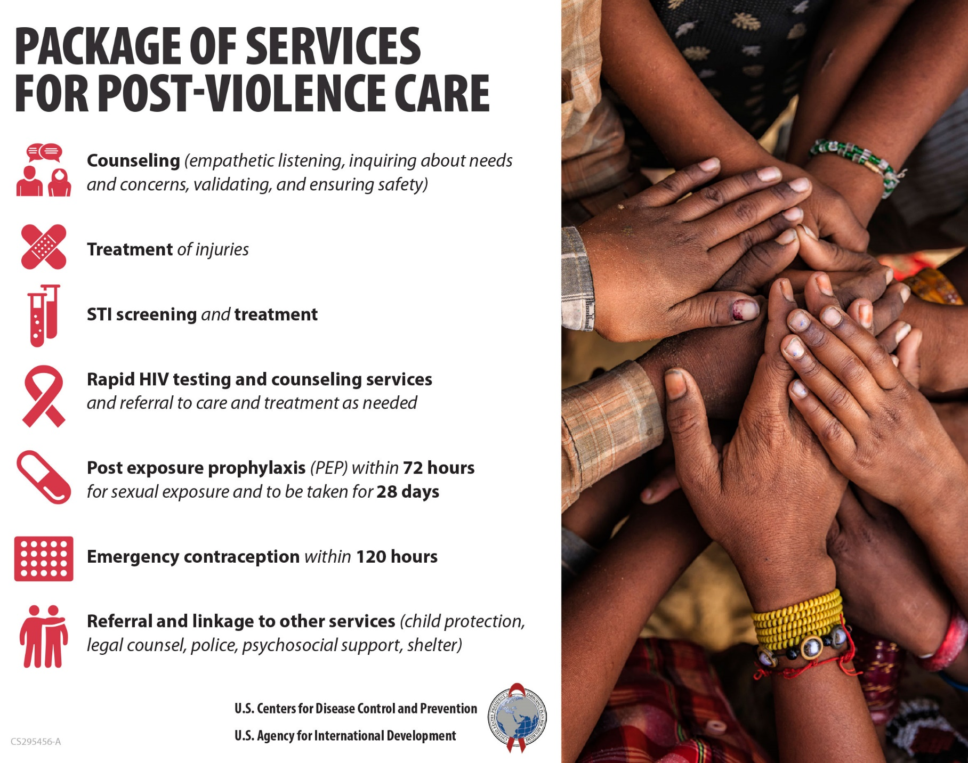

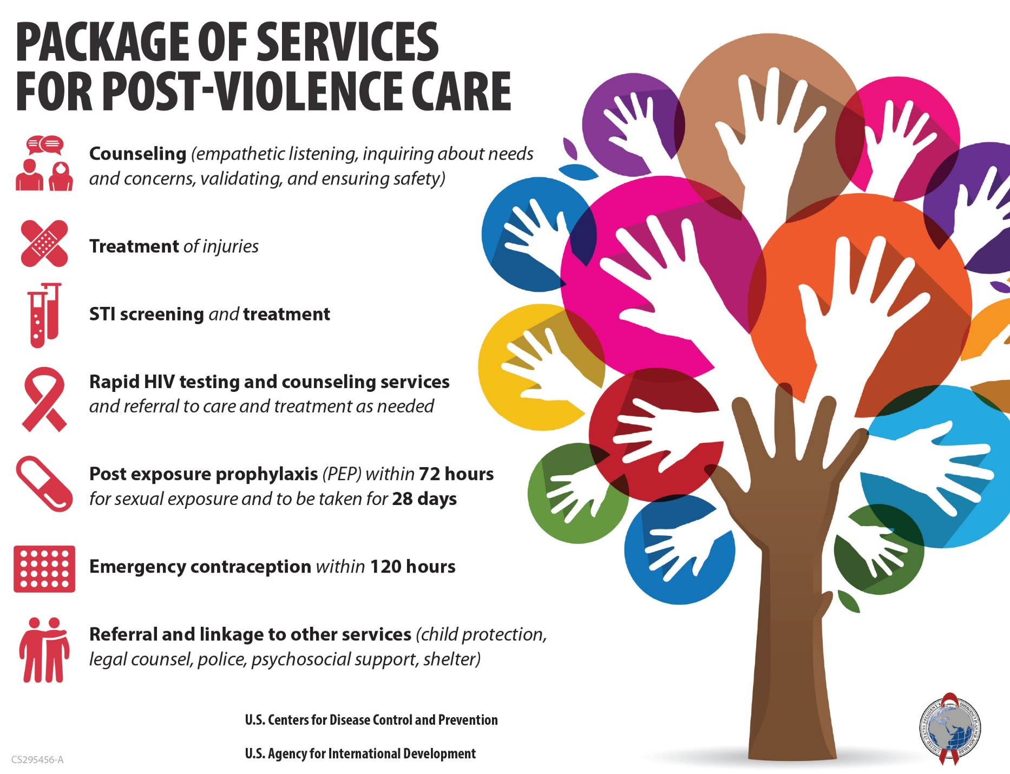
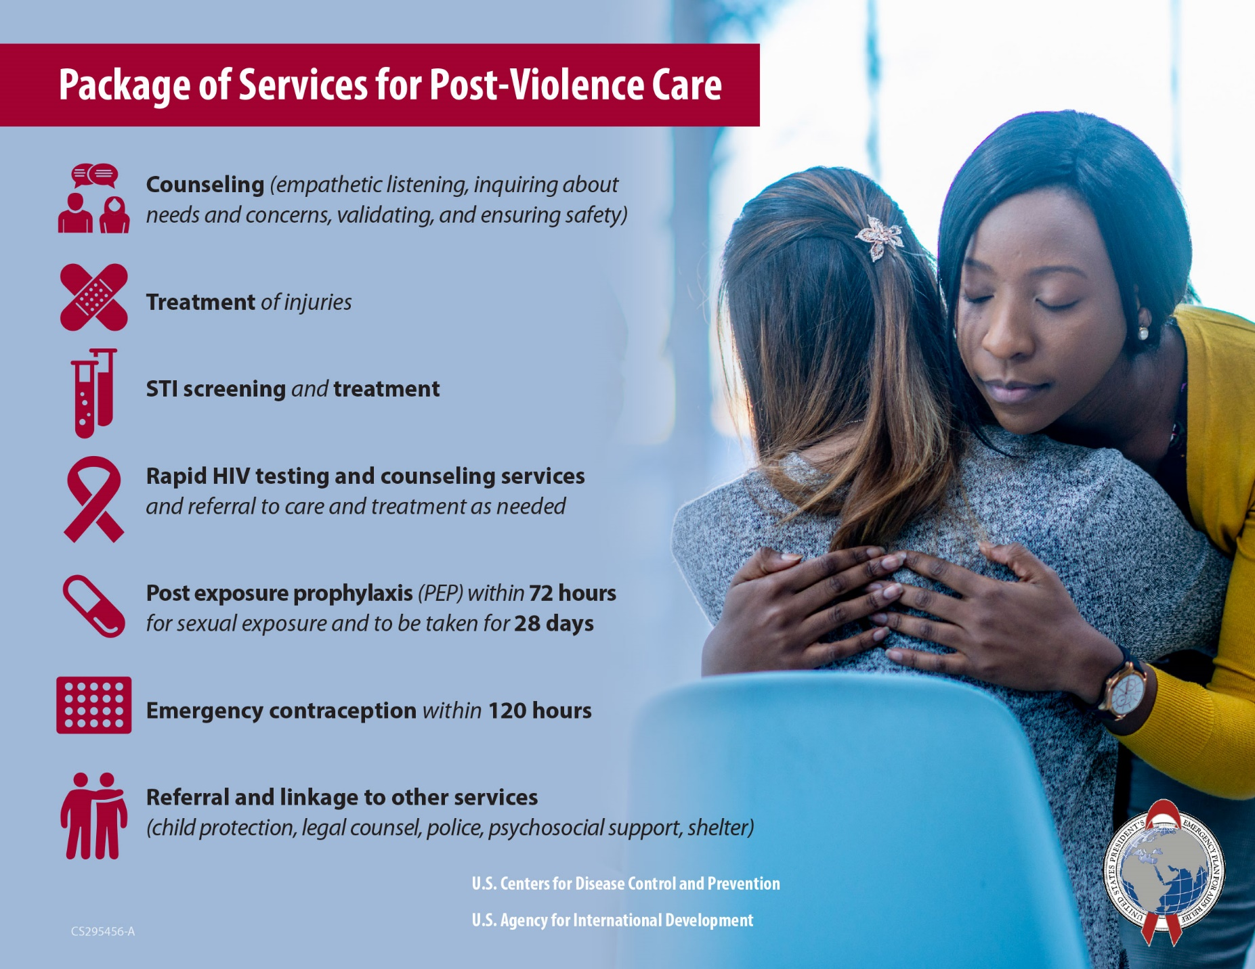

First-line support is immediate counseling offered to someone who just disclosed violence and/or reported for services. LIVES stands for “Listen, inquire about needs and concerns, validate, enhance safety, and support.” More here: https://www.who.int/reproductivehealth/publications/violence/vaw-clinical-handbook/en/.

