Optional Module 3: Household Dietary Diversity
This optional module reflects the guidelines given in the Household Dietary Diversity Score (https://www.fantaproject.org/sites/default/files/resources/HDDS_v2_Sep06_0.pdf)
published in 2006 by the Food and Nutrition Technical Assistance III Project (FANTA), which was implemented by FHI 360. Additional guidelines may be found in this Food and Agriculture Organization (FAO) publication.

No. | Questions | Coding Categories
3.1 | Now I would like to ask you about the types of foods that you or anyone in your household ate yesterday during the day and at night.  Read the list of foods one at a time.  Circle ‘1’ for Yes if anyone in the household ate the food listed in the question.  Circle ‘0’ if no one in the household ate the food.  Update list a) with locally available grains. |  | Yes | No
 |  | - Any bread, rice, noodles, biscuits; any food made from millet, sorghum, maize, rice, wheat, or [INSERT ANY LOCAL FOODS, SUCH AS UGALI, NSHIMA, OR ANY OTHER LOCALLY AVAILABLE GRAIN]? | 1 | 0
 |  | - Any potatoes, yams, manioc, cassava, or other foods made from roots or tubers? | 1 | 0
 |  | - Any vegetables? | 1 | 0
 |  | - Any fruits? | 1 | 0
 |  | - Any beef, pork, lamb, goat, rabbit, wild game, chicken, duck, or other birds; liver, kidney, heart, or other organ meats? | 1 | 0
 |  | - Any eggs? | 1 | 0
 |  | - Any fresh or dried fish or shellfish? | 1 | 0
 |  | - Any foods made from beans, peas, lentils, or nuts? | 1 | 0
 |  | - Any cheese, yogurt, milk, or other milk products? | 1 | 0
 |  | - Any foods made with oil, fat, or butter? | 1 | 0
 |  | - Any sugar or honey? | 1 | 0
 |  | - Any other foods, such as condiments, coffee, tea? | 1 | 0

―END OF OPTIONAL MODULE―

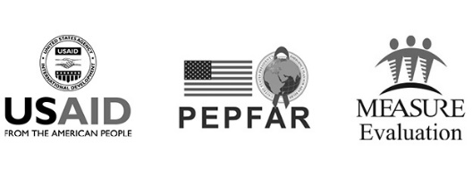
This publication was produced with the support of the United States Agency for International Development (USAID) under the terms of MEASURE Evaluation cooperative agreement AID-OAA-L-14-00004. MEASURE Evaluation is implemented by the Carolina Population Center, University of North Carolina at Chapel Hill in partnership with ICF International; John Snow, Inc.; Management Sciences for Health; Palladium; and Tulane University. Views expressed are not necessarily those of USAID or the United States government.
TL-19-31b

