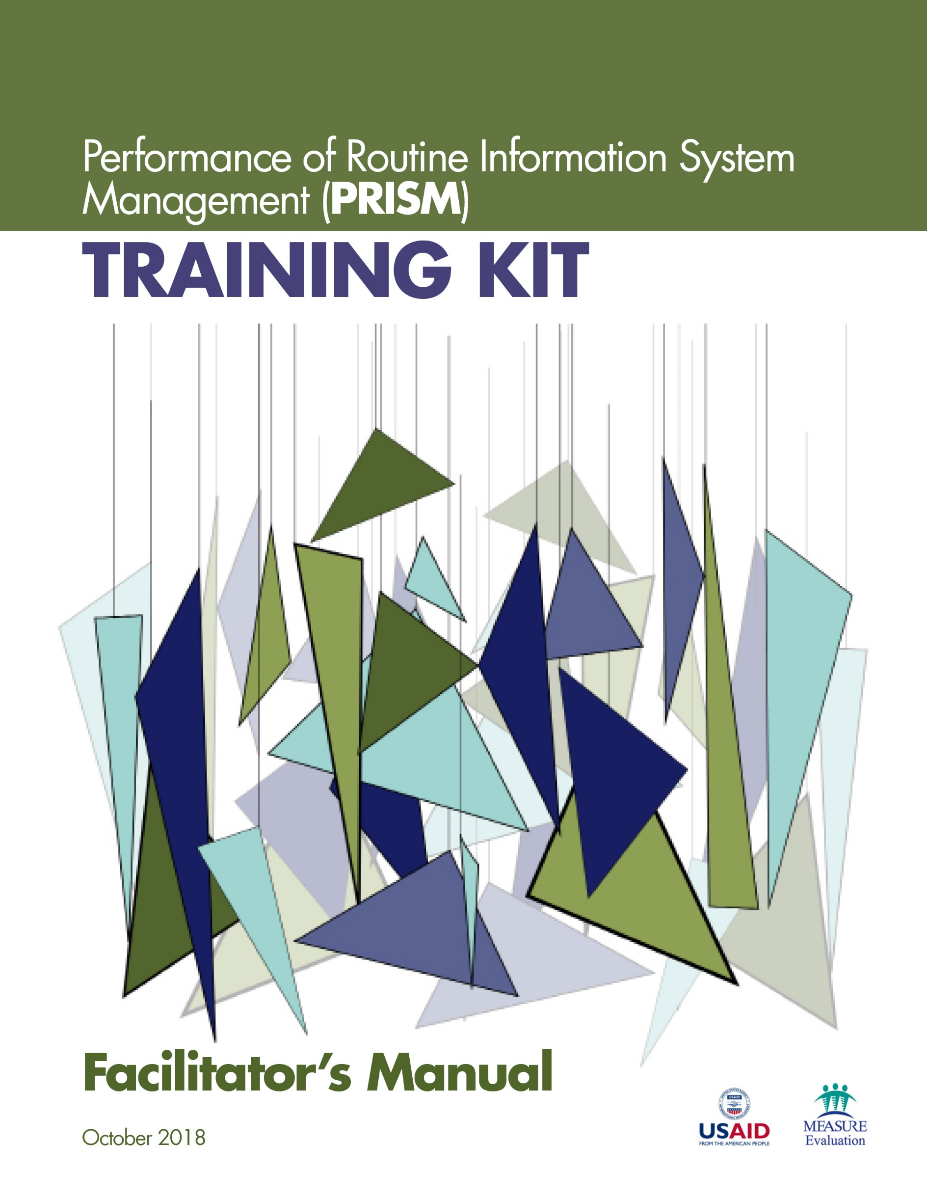

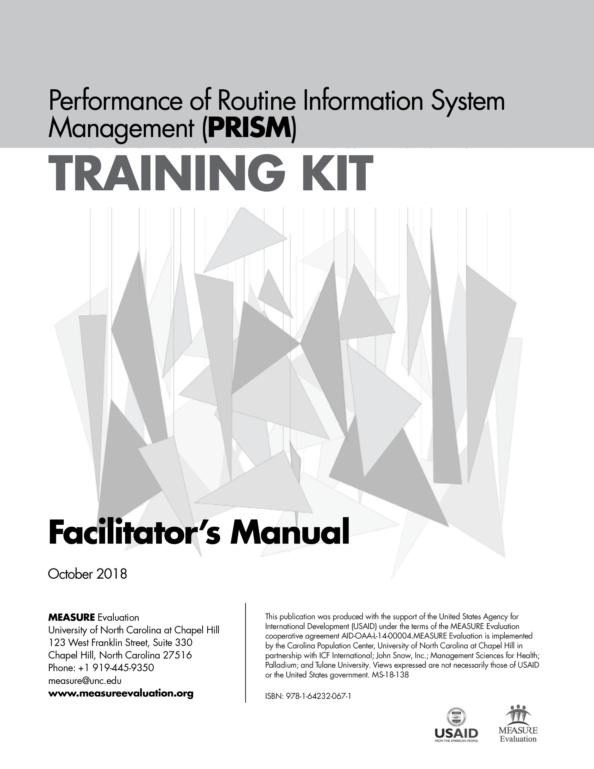

Acknowledgments
MEASURE Evaluation, funded by the United States Agency for International Development (USAID), thanks those who contributed to the updated version of the Performance of Routine Information System Management (PRISM) Series – a collection of tools and supporting materials. It builds on the 2011 version of PRISM, developed by Anwer Aqil, Dairiku Hozumi, and Theo Lippeveld, all then members of MEASURE Evaluation, John Snow, Inc. (JSI), in collaboration with Mounkaila Abdou, JSI, and Alan Johnston, Constella Futures (now Palladium). This updated version draws on best practices and lessons learned from the many countries that have implemented PRISM assessments, as well as the new routine health information system (RHIS) Rapid Assessment Tool, developed by MEASURE Evaluation (available here: https://www.measure
evaluation.org/resources/tools/rhis-rat/routine-health-information-system-rapid-assessment-tool).
First, we wish to acknowledge USAID for its support.
Second, we thank the 80-plus respondents who answered our call for feedback on the original tools. We received feedback from GEMNet-Health partners as well as RHIS professionals from Afghanistan, Bangladesh, Canada, Ethiopia, Ghana, India, Indonesia, Kenya, Lesotho, Liberia, Malawi, Mexico, Namibia, Nepal, Nigeria, Philippines, Senegal, South Africa, Thailand, Uganda, the United States, and Zimbabwe.
Third, we extend our appreciation to the PRISM technical working group (TWG), an internal project advisory group, for its work in updating the tools. Members of the PRISM TWG are Tariq Azim, Alimou Barry, Hiwot Belay, David Boone, Suzanne Cloutier, Marc Cunningham, Mike Edwards, Upama Khatri, Sergio Lins, Moussa Ly, Amanda Makulec, Imelda Moise, and Kolawole Oyediran, from MEASURE Evaluation, JSI; Tara Nutley, from MEASURE Evaluation, Palladium; Sam Wambugu, from MEASURE Evaluation, ICF; David Hotchkiss, from MEASURE Evaluation, Tulane University; Stephen Sapirie, from MEASURE Evaluation, Management Sciences for Health (MSH); and Hemali Kulatilaka, from MEASURE Evaluation, University of North Carolina at Chapel Hill (UNC).
Fourth, we recognize the core team at MEASURE Evaluation for leading the revision effort and for their contributions. Special thanks go to Hiwot Belay, Sergio Lins, Suzanne Cloutier, Tariq Azim, and Jeanne Chauffour of MEASURE Evaluation, JSI, for their extensive work in revising and finalizing the PRISM Series.
Finally, we thank MEASURE Evaluation’s knowledge management team for editorial and production services.

For any questions about the tools or implementing any part of the assessment, please contact:
measure@measureevaluation.org.

Suggested citation:
MEASURE Evaluation. (2018). Performance of Routine Information System Management (PRISM) Training Kit: Facilitator's Manual. Chapel Hill, NC, USA: MEASURE Evaluation, University of North Carolina.

CONTENTS
Abbreviations 7
Overview of the PRISM Series 8
What the 2018 PRISM Series Offers 9
Uses of the PRISM Tools 10
Introduction to the PRISM Training 11
Session 1. Training Content and Orientation 12
Session 2. Introduction to the Health Information System 14
Session 3. Introduction to the Routine Health Information System 16
Session 4. Introduction to the PRISM Framework 18
Session 5. Measuring Data Quality 20
Session 6. Use of Information for Decision Making 22
Session 7. Overview of the Prism Tools 24
Session 8. Assessment Implementation 27
Session 9. Assessment Analysis 29
PRISM Assessment: Training Evaluation Form 30
Appendix 1. Training Agenda 31
Appendix 2. Training Evaluation Form 33

ABBREVIATIONS
eRHIS electronic routine health information system(s)
HIS health information system(s)
LQAS lot quality assurance sampling
MAT Management Assessment Tool
OBAT Organizational and Behavioral Assessment Tool
PRISM Performance of Routine Information System Management
RHIS routine health information system(s)
USAID United States Agency for International Development

Overview of the PRISM Series
Using data to make evidence-informed decisions is still weak in most low- and middle-income countries. Especially neglected are data produced by routine health information systems (RHIS). RHIS comprise data collected at public, private, and community-level health facilities and institutions. These data, gleaned from individual health records, records of services delivered, and records of health resources, give a granular, site-level picture of health status, health services, and health resources. Most are gathered by healthcare providers as they go about their work, by supervisors, and through routine health facility surveys.
When routine data are lacking, or are not used, the results can be lower-quality services, weak infection prevention and control responses, lack of skilled health workers available where they are needed, and weak supply chains for drugs and equipment. These factors contribute to poor health outcomes for people.
MEASURE Evaluation, which is funded by the United States Agency for International Development (USAID), has provided technical and financial assistance to strengthen RHIS for more than 15 years. We have contributed to best practices at the global level and to the strengthening of RHIS data collection, data quality, analysis, and use at the country level. One of the project’s mandates is to strengthen the collection, analysis, and use of these data for the delivery of high-quality health services.
MEASURE Evaluation developed the Performance of Routine Information System Management (PRISM) Framework and suite of tools in 2011 for global use in assessing the reliability and timeliness of an RHIS, in making evidence-based decisions, and in identifying gaps in an RHIS so they can be addressed and the system can be improved. The framework acknowledges the broader context in which RHIS operate. It also emphasizes the strengthening of RHIS performance through a system-based approach that sustains improvements in data quality and use. PRISM broadens the analysis of RHIS performance to cover three categories of determinants that affect performance:
- Behavioral determinants: The knowledge, skills, attitudes, values, and motivation of the people who collect, analyze, and use health data
- Technical determinants: The RHIS design, data collection forms, processes, systems, and methods
- Organizational determinants: Information culture, structure, resources, roles, and responsibilities of key contributors at each level of the health system

Figure 1. PRISM Framework

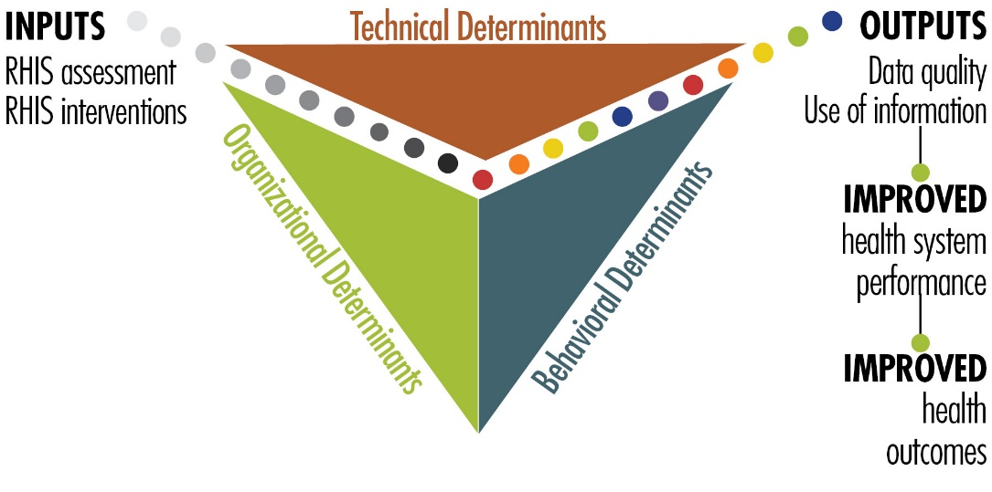

What the 2018 PRISM Series Offers
With USAID’s support, MEASURE Evaluation has revised the PRISM Tools and developed other elements, based on the PRISM Framework, to create a broad array of materials: the “PRISM Series.” It’s available on the MEASURE Evaluation website (https://www.measureevaluation.org/prism) and has the following components:
- PRISM Toolkit
- PRISM Tools (this is the fundamental manual of the PRISM Toolkit)
- PRISM Tools to Strengthen Community Health Information Systems
- Analysis Tool for Data from a PRISM Assessment
- PRISM User’s Kit (consisting of four guidance documents)
- Preparing and Conducting a PRISM Assessment
- Using SurveyCTO to Collect and Enter PRISM Assessment Data
- Analyzing Data from a PRISM Assessment
- Moving from Assessment to Action
- PRISM Training Kit
- Participant’s Manual
- Facilitator’s Manual (this document)
- 9 PowerPoint training modules
This new, more comprehensive PRISM Series is useful for designing, strengthening, and evaluating RHIS performance and developing a plan to put the results of a PRISM assessment into action.
The revised “PRISM Tools”—the PRISM Series’ core document—offers the following data collection instruments:
RHIS Overview Tool
This tool examines technical determinants, such as the structure and design of existing information systems in the health sector, information flows, and interaction of different information systems. It looks at the extent of RHIS fragmentation and redundancy and helps to initiate discussion of data integration and use.
Performance Diagnostic Tool
This tool determines the overall level of RHIS performance: the level of data quality and use of information. This tool also captures technical and organizational determinants, such as indicator definitions and reporting guidelines, the level of complexity of data collection tools and reporting forms, and the existence of data-quality assurance mechanisms, RHIS data use mechanisms, and supervision and feedback mechanisms.
Electronic RHIS Performance Assessment Tool
This tool examines the functionality and user-friendliness of the technology employed for generating, processing, analyzing, and using routine health data.
Management Assessment Tool
The Management Assessment Tool (MAT) is designed to take rapid stock of RHIS management practices and to support the development of action plans for better management.
Facility/Office Checklist
This checklist assesses the availability and status of resources needed for RHIS implementation at supervisory levels.
Organizational and Behavioral Assessment Tool
The Organizational and Behavioral Assessment Tool (OBAT) questionnaire identifies behavioral and organizational determinants, such as motivation, RHIS self-efficacy, task competence, problem-solving skills, and the organizational environment promoting a culture of information.

Uses of the PRISM Tools
These PRISM tools can be used together to gain an in-depth understanding of overall RHIS performance, to establish a baseline, and to rigorously evaluate the progress and effectiveness of RHIS strengthening interventions every five years, contributing to the national RHIS strategic planning process. Each PRISM tool can also be used separately for in-depth analysis of specific RHIS performance areas and issues.

Introduction to the PRISM Training
To support the use of the PRISM Tools, we have developed a curriculum consisting of nine training sessions. These are:
- Training Content and Orientation
- Introduction to the Health Information System
- Introduction to the Routine Health Information System
- Introduction to the PRISM Framework
- Measuring Data Quality
- Use of Information for Decision Making
- Overview of the PRISM Tools
- Assessment Implementation
- Assessment Analysis
The Facilitator’s Manual explains how to conduct the training sessions and complements the Participant’s Manual. Both accompany the nine training PowerPoint slide decks.
The in-country team responsible for the management of the PRISM assessment should go through this training to become familiar with the overall concepts of health information systems and the PRISM Framework, and gain in-depth understanding on the PRISM Tools, how to conduct the assessment, and how to analyze and use the assessment data. As such, the primary audiences of this training are the health managers, supervisors, and planners directly involved with managing the PRISM assessment.
The training is conducted over three days (see Appendix 1 in the Facilitator’s Guide for an agenda). The Facilitator’s Guide presents the learning objectives for each session, as well as the topics covered, a session plan (including session duration), the teaching method to use, materials needed for the session, and activities, such as group work. Information on how to present the training materials is also provided (e.g., PowerPoint presentation, plenary discussion, and handouts). Session 7 (Overview of the PRISM Tools) and Session 8 (Assessment Implementation) are the longest. Sufficient time for questions and answers (Q&A) and practice should be spent in these two sessions to gain a thorough understanding of the tools and the assessment method. We also recommend scheduling fifteen-minute breaks in the morning and afternoon and one-hour lunch breaks every day to create a relaxed environment during training, which by itself could be very intensive in nature. Adult learning method is followed throughout the sessions.
This training can be applicable for the data collectors also. However, for the data collectors, Session 7 (Overview of the PRISM Tools) is the most appropriate and their training should provide in-depth understanding of each question, the skip patterns, and the data collection norms for all the tools. This includes a practice session and a field test in a health facility setting. Those directly involved in electronic data entry should be thoroughly trained on the PRISM electronic data entry tools and the PRISM Analysis Tool (available at https://www.measureevaluation.org/prism).
.

Session 1. Training Content and Orientation
Session duration: 1 hour
Session Learning Objectives
By the end of this session, participants will be able to:
- List their expectations about the training
- Explain the training objectives, content, agenda, and methods
- Set training rules
Topics Covered
- Training objectives and content
- Training methods
- Training agenda (schedule)
- Training evaluation process
- Training rules
Teaching Methods
- Facilitator presentation
- Plenary discussion and Q&A
Materials Needed
- PowerPoint presentation, “Session 1: Training Content and Orientation”
- Flip chart paper
- Markers
- Pens or pencils
- Projection equipment
- Handout: Participant’s Manual

Session Plan
Time | Title and Description | Methods
15 minutes | Activity 1. Icebreaker exercise: participant introductions  Engage participants to introduce themselves using an icebreaker game | Icebreaker game
15 minutes | Activity 2. Participant’s expectations  Engage participants to express their expectations about the training | Plenary session  Brainstorming
30 minutes | Activity 3. Training objectives, content, methods, agenda, evaluation process, and rules  The facilitator presents Session 1 slides and engages participants in discussing the agenda and setting training rules | Present PowerPoint Session 1  Large group discussion  Handout: Participant’s Manual

Session 2. Introduction to the Health Information System
Session duration: 1 hour
Session Learning Objectives
By the end of this session, participants will be able to:
- Define the health system and its generic functions
- Describe the relationship between the health system and the health information system (HIS)
- Describe the relationship between the health system and the routine health information system (RHIS)
Topics Covered
- Health system components
- Functions and outcomes of the health system
- HIS and its importance
- Core components and standards of the HIS
Teaching Methods
- Lecture/facilitator presentation
- Exercise and group work
- Plenary discussion and Q&A
Materials Needed
- PowerPoint presentation: “Session 2: Introduction to the Health Information System”
- Writing board or large pad of display paper and an easel, or a personal laptop
- Markers
- Pens or pencils
- Projection equipment
- Handout: Participant’s Manual

Session Plan
Time | Title and Description | Methods
30 minutes | A quick review of the health system and the HIS  - Health system and its six components/building blocks; outcomes of the health system  - HIS and its functions  - Categories of the HIS, based on data source and data collection frequency  - Contribution of HIS to addressing health challenges at the three management levels of the health system  - Core components of a well-functioning HIS | Lecture; present PowerPoint Session 2 (Slides 1 to 9)  Discussions  Handout: Participant’s Manual
30 minutes | Brainstorm  - Enablers of and barriers to:  - Assuring HIS data quality  - HIS information use | Present PowerPoint Session 2 (Slide 10)  Plenary discussion, listing on flip chart

Session 3. Introduction to the Routine Health Information System
Session duration: 30 minutes
Session Learning Objectives
By the end of this session, participants will be able to:
- Define the key data collection concepts
- Explain the roles of the RHIS in health system management
- Describe the data management processes and needs
- Describe the importance and structure of good RHIS data-management practices
- Identify and analyze possible constraints in the RHIS data management processes
Topics Covered
- Data collection concepts
- Overview and types of data collection
- Patient/client data
- Health services data
- Resources data (human resources, commodities, finance, and infrastructure)
- Data aggregation
- Data flow
- Data reporting and transmission
- RHIS data management
Teaching Methods
- Lecture/facilitator presentation
- Exercise and group work
- Plenary discussion and Q&A
Materials Needed
- PowerPoint presentation: “Session 3: Introduction to the Routine Health Information System”
- Projection equipment
- Large pad of paper or writing board and an easel, or a personal laptop
- Markers
- Pens or pencils
- Handout: Participant’s Manual
Session Plan
Time | Title and Description | Methods
30 minutes | A quick review of the RHIS  - Present the basic concepts of data collection  - Explain the roles of the RHIS in management of the health system  - Provide examples of RHIS subsystems  - Present and discuss the RHIS data management processes | Lecture; present PowerPoint Session 3  Discussions  Handout: Participant’s Manual

Session 4. Introduction to the PRISM Framework
Session duration: 45 minutes
Session Learning Objectives
By the end of this session, participants will be able to:
- Define “good” RHIS performance (to measure production, management, and use of high-quality data)
- Demonstrate an understanding of the three determinants of RHIS performance
- Explain the components and uses of the PRISM Framework and the PRISM Conceptual Model
- Identify and understand the factors influencing RHIS performance
Topics Covered
- Introduction to the definition of RHIS performance
- The PRISM Framework
- Determinants of RHIS performance
Teaching Methods
- Lecture/facilitator presentation
- Exercise and group work
- Plenary discussion and Q&A
Material Needed
- PowerPoint presentation: Session 4: “Introduction to the PRISM Framework”
- Large pad of display paper and an easel, or a personal laptop
- Markers
- Pens or pencils
- Poster paper for sticky notes
- Projection equipment
- Handout: Participant’s Manual

Session Plan

Time | Title and Description | Methods
45 minutes | Introduction to the PRISM Framework for assessing RHIS performance  - RHIS performance definition  - PRISM Framework  - PRISM Conceptual Model  - Examples of factors influencing RHIS performance | Lecture; present PowerPoint Session 4  Discussions  Handout: Participant’s Manual

Session 5. Measuring Data Quality
Session duration: 1 hour
Session Learning Objectives
By the end of this session, participants will be able to:
- Describe the data quality concept and definition
- Explain the dimensions of data quality
- Understand and explain the importance of and responsibilities for maintaining the quality of data across the different RHIS management levels
- Define, calculate, and interpret the main data quality metrics
- Identify the main types of data quality problems
Topics Covered
- Data quality
- Dimensions of data quality
- Data quality metrics
- Common threats to data quality
Teaching Methods
- Lecture/facilitator presentation
- Plenary discussion and Q&A
Materials Needed
- PowerPoint presentation: Session 5: “Measuring Data Quality”
- Large pad of display paper and an easel
- Markers
- Pens and pencils
- Projection equipment
- Handout: Participant’s Manual

Session Plan
Time | Title and Description | Methods
60 minutes | Introduction to data quality  - Present the data quality concept and definition  - Present the dimensions of data quality  - Present the data quality performance metrics  - Accuracy (explain if there is any overreporting or underreporting)  - Reporting completeness (availability of reports)  - Data completeness (reports with data elements filled out)  - Timeliness  - Discuss common threats to data quality | Lecture, present PowerPoint Session 5  Discussions  Handout: Participant’s Manual

SESSION 6. USE OF INFORMATION FOR DECISION MAKING
Session duration: 45 minutes
Session Learning Objectives
By the end of this session, participants will be able to:
- Explain the importance of using data to inform program planning and policy development
- Appreciate how data use interventions can improve a HIS
- Define data demand and data use
- Identify barriers for using data/information
Topics Covered
- Data-informed decision making process
- Data demand and use
- Barriers to using data/information
- Commitment to using data
Teaching Methods
- Lecture/facilitator presentation
- Plenary discussion and Q&A
- Brainstorm with participants
Materials Needed
- PowerPoint presentation: Session 6: “Use of Information for Decision Making”
- Large pad of display paper and an easel, or a personal laptop
- Markers
- Pens or pencils
- Projection equipment
- Handout: Participant’s Manual

Session Plan
Time | Title and Description | Methods
25 minutes | Using information for decision making  - Value of data  - Data informed decision making process  - Data demand and use  - Determinant of data demand and use. | Lecture, present PowerPoint Session 6 (Slides 1 to 7)  Discussions  Handout: Participant’s Manual
20 minutes | Brainstorm:  - Identify and list the main barriers to using or getting others to use data or information  - Way forward to establishing culture of information | Present PowerPoint Session 6 (Slides 8 and 9)  Plenary discussion

SESSION 7. OVERVIEW OF THE PRISM TOOLS
Session duration: 7 hours and 45 minutes
Session Learning Objectives
By the end of this session, participants will be able to:
- Describe how the PRISM Tools are organized
- Link each PRISM tool to the PRISM Framework
- Explain the purpose of each tool to diagnose RHIS performance and how to use it
Topics Covered
- Purpose of a PRISM assessment
- The PRISM Tools
- Linkage between the PRISM Tools and the PRISM Conceptual Model
- Overview of the PRISM Tools to assess and improve RHIS performance
- RHIS Overview Tool
- RHIS Performance Diagnostic Tool
- Electronic RHIS (eRHIS) Assessment Tool
- Management Assessment Tool (MAT)
- Facility/Office Checklist
- Organizational and Behavioral Assessment Tool (OBAT)
Teaching Methods
- Lecture/facilitator presentation
- Q&A
Materials Needed
- PowerPoint presentation: Session 7: “Overview of the PRISM Tools”
- Projection equipment
- Handouts:
  - Participant’s Manual
  - PRISM Tools

Session Plan
Time | Title and Description | Methods
30 minutes | Overview of tools to assess RHIS performance  - Present the PRISM Tools  - Explain and discuss the purpose of using the PRISM Tools  - Present and explain the linkage between the PRISM Tools and the PRISM Framework (presented in Session 4) | Lecture, present PowerPoint Session 7 (Slides 1 to 6)  Discussions  Handout:  Participant’s Manual
45 minutes | 1. RHIS Overview Tool  - Present the structure and purpose of the RHIS Overview Tool  - Explain the tool’s sections in detail | Lecture, present PowerPoint Session 7 (Slide 7)  Q&A  Handout:  PRISM Tools
120 minutes | 2. RHIS Performance Diagnostic Tool  - Present the structure and purpose of the RHIS Performance Diagnostic Tool  - Explain the tool’s sections in detail | Lecture, present PowerPoint Session 7 (Slides 8 to 10)  Q&A  Handout:  PRISM Tools
90 minutes | 3. eRHIS Performance Assessment Tool  - Present the structure and purpose of the eRHIS Performance Assessment Tool  - Explain the tool’s sections in detail  - Explain the technical factors that this tool, in combination with the Overview Tool and Performance Diagnostic Tool, measures | Lecture, present PowerPoint Session 7 (Slide 11)  Q&A  Handout:  PRISM Tools
30 minutes | 4. Management Assessment Tool (MAT)  - Present the structure and purpose of the MAT  - Explain the tool’s sections in detail | Lecture, present PowerPoint Session 7 (Slide 12)  Q&A  Handout:  PRISM Tools
30 minutes | 5. Facility/Office Checklist  - Present the structure and purpose of the Facility/Office Checklist  - Explain the tool’s sections in detail | Lecture, present PowerPoint Session 7 (Slide 13)  Q&A  Handout:  PRISM Tools
120 minutes | 6. Organizational and Behavioral Assessment Tool (OBAT)  - Present the structure and purpose of the OBAT  - Explain the tool’s sections in detail | Lecture, present PowerPoint Session 7 (Slides 14 to 17)  Q&A  Handout:  PRISM Tools

SESSION 8. ASSESSMENT IMPLEMENTATION
Session duration: 1 hour and 45 minutes
Session Learning Objectives
By the end of this session, participants will be able to:
- Describe the PRISM assessment implementation steps
- Describe the criteria for adapting the PRISM Tools to the local context
- Explain the sampling method
- Become familiar with PRISM electronic data entry
Topics Covered
- PRISM implementation steps in pre-assessment, while conducting an assessment, and post data-collection
- Review of sampling methods, including lot quality assurance sampling (LQAS)
- Overview of PRISM electronic data entry
Teaching Methods
- Lecture/facilitator presentation
- Demonstration of how to use the data entry
- Plenary discussion and Q&A
Materials Needed
- PowerPoint presentation: Session 8: “Assessment Implementation”
- Projection equipment
- Laptop computers, tablets, or smart phones
- Handouts:
  - Participant’s Manual
  - PRISM User’s Kit: Preparing and Conducting a PRISM Assessment
  - PRISM User’s Kit: Using SurveyCTO to Collect and Enter PRISM Assessment Data

Session Plan
Time | Title and Description | Methods
30 minutes | Assessment implementation  - Present the steps of PRISM implementation  - Explain how to adapt the PRISM Tools to the local context.  - Sampling method; a quick overview of the LQAS method, which is primarily used during PRISM application | Lecture, present PowerPoint Session 8 (Slides 1 to 11)  Discussions  Handout:  Participant’s Manual  Handout: PRISM User’s Kit: Preparing and Conducting a PRISM Assessment
30 minutes | PRISM data collection and entry  - Introduce the electronic data collection application (SurveyCTO) for data collection during the PRISM assessment  - Present “Using SurveyCTO to Collect and Enter PRISM Assessment Data” (from the User’s Kit). Guide participants to install SurveyCTO on their laptops, tablets, or smart phones and upload form definition files, which are available for download here: https://www.  measureevaluation.org/prism. | Present PowerPoint Session 8 (Slide 12)  Discussions  Handout: PRISM User’s Kit: Using SurveyCTO to Collect and Enter PRISM Assessment Data
45 minutes | Using SurveyCTO for PRISM assessment data collection and entry  Facilitator demonstrates on a big screen how to enter data collected during the PRISM assessment using SurveyCTO | PowerPoint Session 8 (Slide 15)  Handout: PRISM User’s Kit: Using SurveyCTO to Collect and Enter PRISM Assessment Data

SESSION 9. ASSESSMENT ANALYSIS
Session duration: 1 hour and 30 minutes
Session Learning Objectives
By the end of this session, participants will be able to:
- Explain how to analyze PRISM assessment data
- Become familiar with the types of analyses performed in several countries
- Describe examples of strengthening interventions based on PRISM assessment findings
Topic Covered
- Analyses using each PRISM tool
- RHIS Performance Diagnostic Tool
- Management Assessment Tool
- Organizational and Behavioral Assessment Tool
- Facility/Office Checklist
- Results overview
- Examples of RHIS strengthening interventions
Teaching Methods
- Lecture/facilitator presentation
- Plenary discussion and Q&A
Material Needed
- PowerPoint presentation: Session 9: “Assessment Analysis”
- Projection equipment
- Handouts:
  - Participant’s Manual
  - PRISM User’s Kit: Analyzing Data from a PRISM Assessment
  - PRISM User’s Kit: Moving from Assessment to Action

Session Plan
Time | Title and Description | Methods
60 minutes | Assessment analysis  - Present and discuss the types of analyses by using each PRISM tool  - RHIS Performance Diagnostic Tool  - MAT  - OBAT  - Facility/Office Checklist  - Explain the analyses performed in selected countries  - Present, interpret, and discuss the template of PRISM’s overall results  - Provide examples of strengthening interventions, by RHIS performance determinant/factor | Lecture, present PowerPoint Session 9 (Slides 1 to 20)  Discussions  Handouts: Participant’s Manual; PRISM User’s Kit: Analyzing Data from a PRISM Assessment; PRISM User’s Kit: Moving from Assessment to Action
30 minutes | Assessment analysis (continued)  - Present, interpret, and discuss the template of PRISM’s overall results  - Provide examples of strengthening interventions, by RHIS determinant or factor | Lecture, present PowerPoint Session 9 (Slides 21 to 25)  Discussions  Handouts: Participant’s Manual; PRISM User’s Kit: Analyzing Data from a PRISM Assessment; PRISM User’s Kit: Moving from Assessment to Action

PRISM Assessment: Training Evaluation Form
At the end of Day 3 (the last training day), during the closing session, the facilitator will distribute the Training Evaluation Form (Appendix 2) to all participants and ask them to fill it out, individually and anonymously, in order to provide their feedback on the training. Participants should return their completed forms to the facilitator.

Appendix 1. Training Agenda

Training Agenda

Performance of Routine Information System Management (PRISM) Assessment Training
Place: Date:
Page 1 of 2
Time | Topics
DAY 1
9:00: – 9:30 | Registration
9:30 – 10:30 | Opening of the training  - Welcome remarks  - Introductions (participants and facilitators)  - Participant expectations  - Session 1: Training Content and Orientation
10:30 – 11:00 | Tea break
11:00 – 12:00 | Session 2: Introduction to the Health Information System
12:00 – 12::30 | Session 3: Introduction to the Routine Health Information System
12:30 – 13:30 | Lunch
13:30 – 14:15 | Session 4: Introduction to the PRISM Framework
14:15 – 15:15 | Session 5: Measuring Data Quality
15:15 – 15:45 | Tea break
15:45 – 16:30 | Session 6: Use of Information for Decision Making
DAY 2
9:00 – 9:15 | Recap of DAY 1
9:15 – 10:30 | Session 7: Overview of the PRISM Tools (Introduction to PRISM Tools and the RHIS Overview Tool)
10:30 – 11:00 | Tea break
11:00 – 12:30 | Session 7: Overview of the PRISM Tools (Performance Diagnostic Tool)
12:30 – 13:30 | Lunch
13:30 – 14:00 | Session 7: Overview of the PRISM Tools (Performance Diagnostic Tool, continued)
14:00 – 15:30 | Session 7: Overview of the PRISM Tools (eRHIS Performance Assessment Tool)
15:30 – 16:00 | Tea break
16:00 – 16:30 | Session 7: Overview of the PRISM Tools (Management Assessment Tool [MAT])
16:30 – 17:00 | Session 7: Overview of the PRISM Tools (Facility/Office Checklist)
DAY 3
9:00 – 9:15 | Recap of DAY 2
9:15 – 10:30 | Session 7: Overview of the PRISM Tools (Organizational and Behavioral Assessment Tool [OBAT])
10:30 – 11:00 | Tea break
11:00 – 11:45 | Session 7: Overview of the PRISM Tools (OBAT, continued)
11:45 – 13:00 | Session 8: Assessment Implementation
13:00 – 14:00 | Lunch
14:00 – 14:30 | Session 8: Assessment Implementation, continued
14:30 – 16:00 | Session 9: Assessment Analysis
16:00 – 16:30 | Tea break
16:30 – 17:00 | Q&A; closing

Appendix 2. Training Evaluation Form
PRISM Training Evaluation Form
Place: Date:
For each training session listed below, please answer the following questions:
- How useful was the training session? Circle the response that best represents your opinion.
- Did the training session contain information that was new to you? Circle Yes or No.

Session |  | How useful was the training session? |  |  | New information?
2 | Introduction to the Health Information System | Not useful | Somewhat useful | Very useful | No | Yes
3 | Introduction to Routine Health Information System | Not useful | Somewhat useful | Very useful | No | Yes
4 | Introduction to the PRISM Framework | Not useful | Somewhat useful | Very useful | No | Yes
5 | Measuring Data Quality | Not useful | Somewhat useful | Very useful | No | Yes
6 | Use of Information for Decision Making | Not useful | Somewhat useful | Very useful | No | Yes
7 | Overview of the PRISM Tools | Not useful | Somewhat useful | Very useful | No | Yes
8 | Assessment Implementation | Not useful | Somewhat useful | Very useful | No | Yes
9 | Assessment Analysis | Not useful | Somewhat useful | Very useful | No | Yes

Comments or suggestions:
Page 1 of 2

Overall
How was the length of the training? | Too short | Just right | Too long
How would you rate the amount of information presented? | Too little | Just right | Too much
How would you rate the level of detail of the information presented? | Too little | Just right | Too much
How was the pace of training? | Too slow | Just right | Too fast
Was the content of the materials distributed adequate? | Too short | Just right | Too long
Were the sessions presented in a logical order? | No | Somewhat | Yes
Were the venue and training logistics satisfactory? | No | Somewhat | Yes
Were the facilitators knowledgeable? | No | Somewhat | Yes
Did the facilitators use effective training methods? | No | Somewhat | Yes
Were your expectations met? | No | Somewhat | Yes
Will you be able to apply what you learned in your work? | No | Yes | Not sure

Please provide any additional comments or suggestions regarding the training:
Page 2 of 2
Thank you for your feedback!

