Routine Health Information System Overview

Overview of Information Systems in Health Sector

Interview HIS Manager at district and sub-national levels
Level: National
Sub-national (district, province, etc)
Name (of district, province, etc) _____________________________
Respondent’s Name:
Function/Title:
Institution:
Department:

1. Mapping existing routine information systems in health sector (OPTIONAL)
Using the sheet 1: “Information system mapping”, list all routine information systems existing in the country/region/district.

This exercise will help you to understand types of health sector information that are included (or not included) by information systems. It will also help to identify duplication of information systems.

- Write down specific names of the information systems.
- Identify types of information covered by each system and check relevant boxes. You may also write comments in the box. For example, an information system for EPI may handle information on drug supplies but it might be limited to vaccines. You can indicate “vaccine only” in the box. Similarly, MCH specific information systems may collect information on service utilization of MCH services only.
- Please describe how information from different information systems are shared. For example, between TB programs and HIV/AIDS programs.

1: Information system mapping (OPTIONAL)
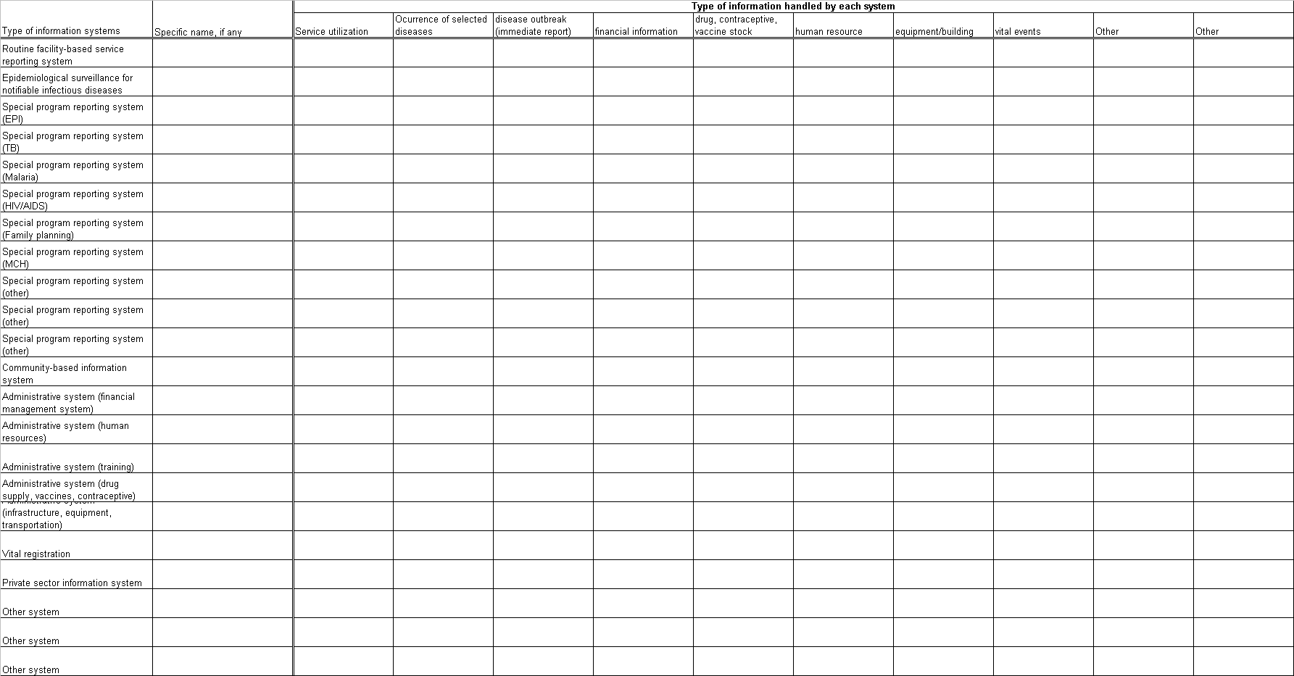

2. Data collection and transmission

Please list all data collection tools/forms that are used at the community/health facility level. If space is not enough, please add an additional sheet of paper.
Facility-based data collection tools: (such as patient registers) | Comments on tools. Is the form easy to use? Enough space to record data? Takes too much time?
Data transmission/reporting forms | Comments on forms. Is the form easy to use? Enough space to record data? Takes too much time?

3. Information flowchart
Using the chart provided on the next page, illustrate the flow of information from community to health facility, health facility to district level, district level to regional level, regional level to the central/national level. For each level, please indicate specific departments/job titles which should receive and process information received from a lower level.

This exercise will help you to clarify information flows in existing information systems and identify potential problems which affect the performance of the information systems.

- If some levels, e.g. community level and regional level are not relevant to systems that you are examining, please omit them from the exercise.
- Please be as specific in identifying information sources and data transmission points as possible. For example, if different types of facilities have different reporting units at district level, you will want to indicate these different paths of information.
- Add more than one information system to see interactions between information systems and how complicated or simple information flows are in your health system. You can see how basic routine health information system’s information flow interacts with special program information systems such as EPI, HIV/AIDS, and Malaria.
- You can be creative in indicating different information flows in different colors. For example, you can indicate the data aggregation process in red and the information feedback process in blue color. Or General RHIS in green and EPI in pink, etc.

Information flowchart
National/Central level
Regional level
District (office) level
Facility Level
Community level
Information system profile

Please use of one set per information system you are assessing. For your convenience, a sheet to summarize your findings is attached at the end.

1: General Information
Name of Information System:

Name and title of person interviewed:

Level that this information system profile was created:

National level Regional Level District level

When was this information system established?

Has this information system gone through major reform?

YES NO

If yes, when and which agency/department led the reform?

2: Mission Statement/Objectives of the information system
Does this information system have a documented mission statement?

YES NO

If Yes, please write down the mission statement:

Does this system have documented purposes/objectives?

YES NO

If Yes, please write down the purposes/objectives.:

Does this system have a list of essential indicators? Please obtain the copy of the list of essential indicators.

YES NO

If yes, the number of indicators in the list:

Is there a guideline/manual on how to calculate and interpret indicators?

YES NO

3. Information system coverage
Does the system cover all geographical areas of the country/region/district?

YES NO

If No, please indicate areas that are not covered by the information system and explain why.

Does the system include all health facilities/service delivery points in the country/region/district?

YES NO

If not all facilities are included, what percentage of facilities are included in the system?

If not all facilities are included, please indicate types of or characteristics of facilities that are not included in the system.

4. Data collection and transmission
Is there a standard schedule for submitting data from the community level to the facility/district?
YES NO
If, yes, at what frequency does the community level submit data/reports?
Daily Weekly Monthly Quarterly Bi-annually Annually Ad-hoc other
Is there a standard schedule for submitting data from the health facility level to a higher level?
YES NO
If yes, at what frequency does the health facility level submit data/reports?
Daily Weekly Monthly Quarterly Bi-annually Annually Ad-hoc other
Is there a standard schedule for submitting data/reports from the district to a higher level?
YES NO
If yes, at what frequency does the district level submit data/reports?
Daily Weekly Monthly Quarterly Bi-annually Annually Ad-hoc other
Is there a standard schedule for submitting data/reports from the regional level to the national level?
YES NO
If yes, at what frequency does the regional level submit data/reports?
Daily Weekly Monthly Quarterly Bi-annually Annually Ad-hoc other
For community level data collection, who is responsible for collection and reporting of data? If data collection and reporting are done by different people, please explain.

For health facility level data collection, who is responsible for collection and reporting of data? If data collection and reporting are done by different people, please explain.

For health facility level data collection, who is responsible for collection and reporting of data? If data collection and reporting are done by different people, please explain.

At the district level, who or which department is responsible for receipt of data? If not defined, please indicate as “not defined”.

At the regional level, who or which department is responsible for receipt of data? If not defined, please indicate as “not defined”

At the national/central level, who or which level is responsible for receipt of data? If not defined, please indicate as “not defined”

Is there a manual/guideline for data collection?
YES (publication year ) NO

Computers, Software, and access to Internet (Some questions overlap with Office checklist)
Total number of computers at your institution/office: (OPTIONAL)

Type of internet connection available at your institution/office: (OPTIONAL)
Not available Dial-up ASDL Cable Satellite Other ( )
Total number of offices under your supervision: (OPTIONAL)

Total number of offices under your supervision with working computers: (OPTIONAL)

Total number of offices under your supervision with access to the Internet: (OPTIONAL)

Does this information system use computers for data entry?
YES NO (If NO, please skip the following questions and go to 6. Analysis and Reporting Section.)
If YES, at what level is data entry computerized?
Community Health facility/service delivery point District Regional National/Central
If yes, is it a customized application/software program for data handling?
YES NO
If yes, who developed it? ( )
If yes, which year was it introduced? ( )
Is this software shared with other information systems?
YES NO
If yes, which information systems share this software?

If customized software is not used, what computer application is used for data entry? (example: MS Excel)

Is there a manual/guideline for data entry/application use?
YES (Publication year ) NO
Does the application have error check functions such as minimum and maximum data range, data rule violations, and unrealistic numbers
YES NO
If yes, please describe type of error check functions in the application.

Does the application produce tables/graphs/maps?
YES NO
If yes, please indicate types of functions that the application can perform:
Time series chart (weekly, monthly, yearly comparisons) | ( ) | Comparisons by areas (sub-district, district, town, village) | ( )
Comparison by facilities | ( ) | Comparison against district standard | ( )
Does the application allow users to add/revise list of data items/indicators according to the needs?
YES NO
If yes, at what level the modification is allowed?

Does the system have data confidentiality guidelines?
YES (Publication year ) NO

6. Analysis and reporting (This session overlaps with RHIS Performance Diagnostic Tool.)
At what level are data analyzed? Please indicate all levels that analyze data.

Please list titles and years of reports published. Please indicate the latest year/month of publication if the report is periodically published. Please collect sample of reports if possible.
-
-
-
-
-
-
-
-

7: Management Structure/team of the information system
Does this information system have a management committee/team?

YES NO

Please describe the composition of the management committee/team.

If a management committee/team exists, are there job descriptions for its members?

YES NO

If yes, are roles and responsibilities clearly defined?

YES NO

8: Financial resources
What is the total budget allocated to this information system for the last fiscal year?

Does the district office allocate its own budget for management of this information system?

YES NO

If yes, what is the percentage of this information system related budget that was allocated by the district office?

If not 100% of the budget for this information system was allocated by the district office, who provided the remaining budget?

If not 100% of the budget for this information system was allocated by the district office, on what purposes district allocated RHIS budget were used?

How was the budget for this information system determined? Who or what part of the government/health service management allocate budget? On basis of what information budget is allocated?

9: HIS training: Please list training programs that are relevant to this information system.
Components of training programs (components could be a stand-alone training program or parts of a general information system training program) | Does this program component have a training manual? | When the last time was that training with this component took place? | What are the target levels of the training components? Facility/District/Regional/National
a. Supervision of the quality of data collection in facilities
b. Data collection, use of data collection instruments
c. Logistic management of HIS printed supplies
d. Data cleaning, quality control, and processing
e. Data analysis
f. Use of information for decision making
Please obtain copies of training manuals.

