Data Analysis & Presentation Job Aids
Using Data to Monitor and Improve Service Delivery
Training Module for Pre-service Training for Nurses



Contents

Job Aids 3
How to calculate a rate 3
How to calculate a proportion and percentage 4
How to calculate a mean 5
How to calculate a median 5
Calculating coverage 7
Assessing retention 7
Summarizing data 8
Tables 9
Chart and Graphs 10
How to create a graph in Excel 13
Glossary 16

Job Aids
Using Data to Monitor and Improve Service Delivery – Pre-service Training for Nurses

How to calculate a rate
A rate is the number of cases that occur in a population at risk over a given time period. A rate is often expressed per 1,000, 10,000, or 100,000 population. In the first example below (Table 1), we want to know the infant mortality rate of New Zealand, Nigeria, and Russia in 2007. The infant mortality rate in Nigeria was 95.5 (number of cases) per 1,000 live births (population at risk) in 2007.

Table 1: Infant mortality rate per 1000 live births in 2007
Nation | Infant Mortality Rate
New Zealand | 5.7
Nigeria | 95.5
Russia | 11.1

Since the number of cases of a specified outcome depends upon the size of the population being considered, dividing by their population sizes makes two or more groups comparable. In the next example (Table 2), we want to know the incidence rate of tuberculosis (TB) cases in 1997–1998 in Nigeria.

The incidence rate is the number of new cases arising in a given period of time in a specified group of people (population). The incidence rate of tuberculosis was 3,045 ÷ 981,000 = 0.003104 × 100,000 or 310 cases per 100,000 people.

Table 2: TB cases by Local Government Area (LGA), from 1997–1998
Local Government Area | Population (1997–98) | TB Cases
Bwari | 141,000 | 446
Abaji | 25,000 | 79
Kuje | 65,000 | 206
Gwagwalada | 91,000 | 228
Kwali | 85,000 | 269
Municipal | 350,000 | 1,108
Garam | 224,000 | 709
Total | 981,000 | 3,045

How to calculate a proportion and percentage
A proportion is a ratio in which all individuals included in the numerator must also be included in the denominator. In Table 3 below, the proportion of total family planning (FP) clients ages 15–24 at Clinic 1 is the number of youth 15–24 years old (numerator) divided by the total number of FP clients (denominator), or 103 ÷ 305 = 0.34 clients who are ages 15–24.

A percentage is a proportion multiplied by 100. By calculating a percentage, we can compare data across facilities, regions, and countries. It also helps us to better conceptualize what needs to be done. Percentages help us to track progress toward our targets, estimate coverage, measure outcomes, and understand our performance against quality-of-care indicators.

To better illustrate how to calculate a percentage, let us consider an example in which we want to know the percentage of total FP clients ages 15–24. We need to identify the number of youth 15–24 years old served at the clinic (numerator) and the total number of FP clients, of all ages, (denominator) coming to the clinic. Then we divide the numerator by the denominator and multiply by 100.

Using our example below, we know that in Clinic 1, 103 are youth 15–24 years old and there are 305 FP clients in total. In Clinic 2, there are 130 youth 15–24 years old and 764 FP clients. The percentage of FP clients who are ages 15–24 is:
Clinic 1: 103 ÷ 305 = 0.34 × 100 = 34%
Clinic 2: 130 ÷ 764 = 0.17 × 100 = 17%

Table 3: Family planning monthly report
Family Planning Services – Clinic 1
No. of Clients | < 15 years |  | 15–24 |  | 25 |  | Total
No. of Clients | M | F | M | F | M | F
Counseled | 2 | 8 | 53 | 50 | 96 | 96 | 305
Tested | 2 | 8 | 50 | 50 | 95 | 95 | 300
HIV+ | 0 | 0 | 1 | 8 | 11 | 13 | 33

Family Planning Services – Clinic 2
No. of Clients | < 15 years |  | 15–24 |  | 25 |  | Total
No. of Clients | M | F | M | F | M | F
Counseled | 2 | 8 | 69 | 61 | 310 | 314 | 764
Tested | 2 | 8 | 50 | 50 | 295 | 295 | 700
HIV+ | 0 | 0 | 1 | 1 | 36 | 38 | 76

How to calculate a mean
The most commonly investigated characteristic of a dataset is its center, or the point around which the observations tend to cluster. The mean (or average) is calculated by summing all of the observations in a dataset and dividing by the total number of measurements. Using Table 4 below, we want to know the mean CD-4 count of 10 clients.

Table 4: Clinic 1 – CD4 count by client
Client | CD4 Count
Client 001 | 90
Client 002 | 110
Client 003 | 100
Client 004 | 95
Client 005 | 92
Client 006 | 106
Client 007 | 104
Client 008 | 100
Client 009 | 101
Client 010 | 92

The clients at Clinic 1 had a mean CD-4 count of (90+110+100+95+92+106+104+100+101+92) = 990 ÷ 10 = 99. The mean (or average) takes into consideration the magnitude of every observation in a dataset, which makes it sensitive to extreme values. For example, if the data from the table above were accidentally modified and the CD-4 counts of two clients were 9.0 and 11.0 rather than 90 and 110, the mean CD-4 count would be calculated as (9.0+11.0+100+95+92+106+104+100+101+92) = 810 ÷ 10 = 81.

How to calculate a median
The median is not as sensitive to extreme values as the mean because it takes into consideration the ordering and relative magnitude of the values. We therefore use the median when data are not symmetric. (Note that in Table 5 below, most figures cluster between 92 and 106. The numbers 9 and 11 are extreme values and are not part of the cluster. The presence of 9 and 11 make the dataset nonsymmetric). If a list of values is ranked from smallest to largest, then half of the values are greater than or equal to the median and the other half are less than or equal to it. When there is an even number of values in the dataset, the median is the average of the two mid-point values.

Table 5: CD-4 count by client
Client | CD4 Count
Client 001 | 9.0
Client 002 | 11.0
Client 003 | 100
Client 004 | 95
Client 005 | 92
Client 006 | 106
Client 007 | 104
Client 008 | 100
Client 009 | 101
Client 010 | 92

If we rank the values in Table 5, we get: 9.0, 11.0, 92, 92, 95, 100, 100, 101, 104, 106. Since there is an even number of observations, the median is calculated as (95+100) 195 ÷ 2 = 97.5. When there are an odd number of values, the median is the middle value. In the example in Table 6 below, once we rank order the values in the table, we get: 9.0, 11.0, 14.0, 92, 92, 95, 100, 100, 101, 104, 106. The middle value would be 95, so the median CD4-count is 95.

Table 6: CD-4 count by client
Client | CD4 Count
Client 001 | 9.0
Client 002 | 11.0
Client 003 | 100
Client 004 | 95
Client 005 | 92
Client 006 | 106
Client 007 | 104
Client 008 | 100
Client 009 | 101
Client 010 | 92
Client 011 | 14.0

Calculating coverage
Coverage is the extent to which a program reaches its intended target population, institution, or geographic area. Coverage assesses the availability and utilization of services. Examples of coverage indicators for HIV/AIDS care and treatment programs include:
• Number of clients receiving voluntary counseling and testing (VCT) services
• Number of clients provided with antiretrovirals (ARVs)
• Percentage of HIV patients receiving tuberculosis therapy
Below are two examples demonstrating how to calculate coverage.

Example 1 – Availability
To assess the availability of VCT services in two different catchment areas, we want to know the number of VCT clinics per target population in each area. In catchment area #1, there are 14 VCT clinics per 10,000 HIV+ people. In catchment area #2, there are 5 clinics per 10,000 HIV+ people. This information tells us that coverage is higher in catchment area #1.

Example 2 – Utilization
In some cases, coverage is defined as the percentage of the target population receiving or utilizing a service. For example (see Table 7), for an ARV therapy program, if there are 32,000 HIV+ people in one catchment area, the coverage is the percentage of HIV+ people who are receiving ARV services: 23,861 HIV+ receiving ARVs/32,000 HIV+ (target population) = 0.75 × 100 = 75% coverage.

We can see that the program has achieved 75% of its 5-Year ARV target.

Table 7: ART monthly report
 | Number on ARVs
Males | 7,980
Females | 15,881
Cumulative number | 23,861
5-year target | 32,000
% Coverage | 75%

Assessing retention
Program retention refers to a program’s success at delivering the entire package of services to a client. Assessing retention is especially important in clinical programs for which drug adherence is an issue (e.g., TB or HIV/AIDS) and there are multiple steps to completing treatment or services (e.g., immunization, prevention of mother-to-child (PMTCT) HIV programs). To assess retention, we typically look at the percentage of completion of each phase of the service. Using Table 8, we want to assess the retention of the program by calculating 1) the change in the percentage of clients who stayed in the ART program over a six-month period and 2) the percentage achieved toward the expected target.

Table 8: ART monthly report
 | Region 1 | Region 2
Clients on ART at baseline | 488 | 859
Clients on ART at 6 months (current) | 343 | 784
% ART retention | 70% | 91%
5-Year target | 679 | 918
% of 5-Year target achieved | 51% | 85%

To calculate the percentage of clients who stayed in the ART program over time, divide the change by the original number and multiply by 100:

Region 1: (488-343) = 145 ÷ 488 = 0.30 × 100 = 30% decrease in clients = ART Retention is 70%
Region 2: (859-784) = 75 ÷ 859 = 0.09 × 100 = 9% decrease in clients = ART Retention is 91%

To calculate the percentage achieved toward the expected target, divide the number of current clients on ART by the 5-Year Target and multiply by 100.

Region 1: (343 ÷ 679) = 0.51 × 100 = 51% is the 5-Year Target Achieved
Region 2: (784 ÷ 918) = 0.85 × 100 = 85% is the 5-Year Target Achieved

Summarizing data
The two main ways of summarizing data are by using tables and charts or graphs. A table is the simplest way of summarizing a set of observations. A table has rows and columns containing data that can be in the form of absolute numbers, percentages, or both. Graphs are pictorial representations of numerical data and should be designed so that they convey the general patterns of the data by portraying trends, relationships, and comparisons.

To make the graphic as self-explanatory as possible, there are several things to include:
• Give every table or graph a title or heading
• Label the x- and y-axes of a graph; include value labels, such as a percentage sign; and include a legend
• Cite the source of your data and include the date of data collection or publication
• Provide the sample size or the number of people to which the graph is referring
• Include a footnote if the graphic isn’t self-explanatory

Tables
Data in tables are presented as a frequency distribution or relative frequency. A frequency distribution is a set of classes or categories, along with numerical counts that correspond to each category, such as number births in a given year (see Table 9).

Table 9: Number of births by year
Year | Number of births
1900 | 5
1901 | 7
1902 | 9

Relative frequency is the percentage of the total number of observations that appear in that interval. It is calculated by dividing the number within an interval by the total number in the table, and then multiplying by 100. It is the same as computing a percentage for the interval. For example, 35 ÷ 132 = 0.27 × 100 = 27% (see Table 10).

Table 10: Percentage of births by decade between 1900 and 1929
Year | N | Relative frequency (%)
1900–1909 | 35 | 27
1910–1919 | 46 | 34
1920–1929 | 51 | 39
Total | 132 | 100.0
Source: U.S. Census data, 1900–1929.

In Table 10, we have the total number of observations (or n) in the second column, but we can use the relative frequencies for analysis. What do they tell us? We can see across the three decades and what percentage of births occurred in each one. The largest percentage of children was born between 1920 and 1929, compared to the other two decades. We can analyze the data further by calculating the average or mean number of births across 30 years: 132 ÷ 3 = 44; this is the mean number of births. Note that the table has a title, labels for each column, and includes the source of the data.

Chart and Graphs
We’re going to review the most commonly used charts and graphs in Excel and PowerPoint. Bar charts are used to compare data within and among categories. In Figure 1, we’re comparing the categories of data from different sites and categories of data within sites.

Figure 1: Percentage of new enrollees tested for HIV at each site, by quarter
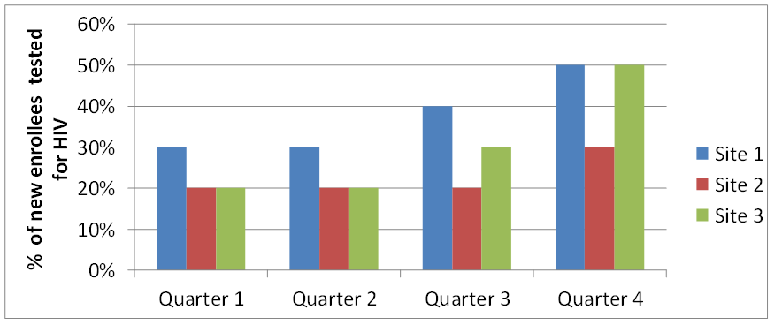
Target
Data Source: Program records, AIDSRelief, January 2009 – December 2009.

Note that the title, labels on the y (vertical) and x (horizontal) axes, and data labels (percentages) help you understand what is included in the graph. The title tells you the population to which the graph is referring, and the y-axis tells you that the values are percentages rather than absolute numbers. To interpret this chart, we look at several things, such as the target, the utilization coverage across sites, the trend over time, and the mean number of enrollees. The target (represented by a line) is to test 50% of new enrollees at each site in each quarter. Only Sites 1 and 3 reached the target; this occurred in Quarter 4.

What is the utilization coverage (% of the target population utilizing services)? In Quarter 1, it is 30% at Site 1 and 20% at the other two sites. What is the trend over time? The utilization coverage for Site 1 increased from 30% in Quarter 1 to 50% in Quarter 4. Note, we can’t calculate the mean because we don’t know the number of enrollees for each site and we can’t average percentages.

A stacked bar chart often is used to represent components of a whole and compare the wholes (or multiple values), such as the number of months clients have been enrolled in HIV care (Figure 2).

Figure 2: Number of months clients have been enrolled in HIV care, by age group
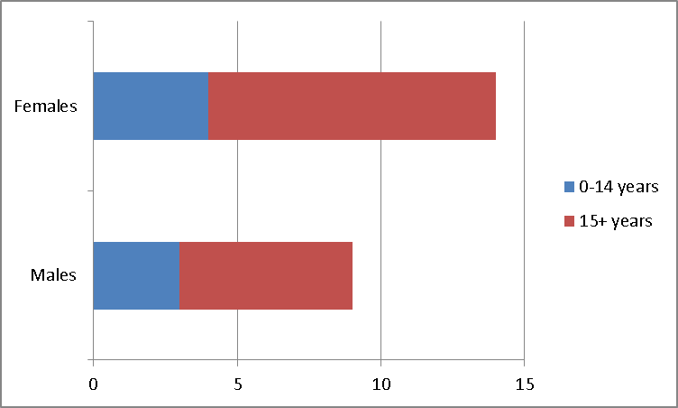
Data Source: Program records, AIDSRelief, January 2009 – December 2009.

Line graphs should be used to display trends over time and are particularly useful when there are many data points. In Figure 3, we have four data points for each clinic.

Figure 3: Number of clinicians working in each ART clinic during years 1–4*

*Includes doctors and nurses.

Pie charts show percentages, or the contribution of each value to a total. A pie chart always totals 100%. The chart below (Figure 4) shows the contribution of patient enrollment each quarter to the entire year. For example, the first quarter contributed the largest the percentage of enrolled patients (59%).

Figure 4: Percentage of all patients enrolled, by quarter

How to create a graph in Excel
- Open Excel.
- Enter the data you want to display in your graph on an empty worksheet.
For example, if you want to show the number of individuals who have been counseled and tested for HIV in your facility (by gender) over the past six months, you would create the following chart.

Month | # men tested | # women tested
Jan | 30 | 41
Feb | 42 | 47
March | 55 | 68
April | 54 | 61
May | 76 | 88
June | 91 | 90

- Use your cursor to select the chart, including the column titles (A, B, C) and the row labels (1, 2, 3).
- Move your cursor up to the top toolbar and select – insert. Options for what you can insert will appear.
- Move your cursor over the section for graphs and select the graph type you want to create (column, line, pie, bar, area, scatter, other).
- After you select the graph type, additional options will appear – in other words, you can create different types of column, line, pie, bar, area, and scatter graphs. Once you select a type, the graph will appear on the worksheet.
- In the example above, we selected – bar, 2-D bar stacked. See the example below.

Mar

- To label your graph axes, first make sure that the chart in your Excel spreadsheet is highlighted (you will see a border around the graph).
- Move your cursor to the top toolbar and select – layout.
- Move your cursor to select – axes titles.
- Select – primary horizontal axis title. Options will appear – none and title below axis. Select – title below axis. This is your x-axis.
- Type the title of your axis in the text box.
- Move your cursor to the top toolbar and select – layout.
- Move your cursor to select – axes titles.
- Select – primary vertical axis title. Options will appear – none, rotated title, vertical title, horizontal title. Select – rotated title. This is your y-axis.
- Type the title of your axis in the text box.
- To title your graph, move your cursor to the top toolbar and select – layout.
- Move your cursor to select – chart title. Options will appear – none, center overlay, above chart.
- Move your cursor to select – above chart.
- Enter your title in the text box.
- Save your work.
- In the example at the top of this page, the titled is represented below the chart.

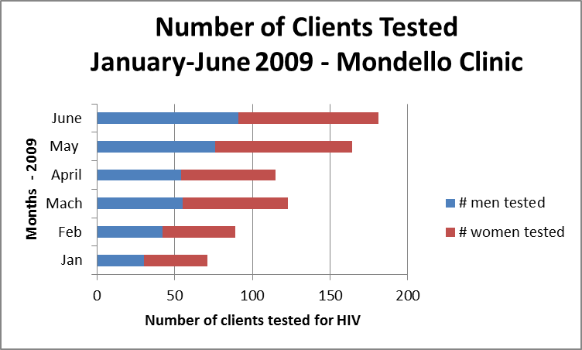
Mar

There are many options for formatting the charts. One way is to click on the feature you want to modify and then right-click and select the appropriate options. You also can determine the location of the chart by clicking on a blank area of the graphic and selecting - move chart. Then select the location at which you want the chart to reside – either in a new Excel worksheet or within the worksheet where you typed the data (as in the example above).
Once the graph is completed, you can copy and paste it onto a PowerPoint slide.

Glossary
Accuracy: A quantitative description of how close a result is to a known quantity.
Aggregate: A collection of data that is assembled for specific analysis.
AIDS Indicator Survey: Provides specific information about a defined cohort, such as epidemic descriptions and demographic prevalence rates.
Analysis: The comparison of program target values to actual values that allows for a conceptual understanding of program performance.
Antenatal care: Prenatal care.
Antiretroviral therapy: Strategies for medicinal treatment of infections by retrovirus, such as HIV.
Catchment area: Refers to the geographic area and population served by a facility.
Cluster of Differentiation 4 (CD4): A primary receptor used by HIV-1 to gain entry into host T cells.
Cohort: A group of subjects with a common defining characteristic that allows for statistical analysis.
Completeness: Describes the comprehensiveness of the dataset.
Coverage: Describes what percentage of a catchment area is encompassed by a program.
Dashboard: A tool used by researchers and/or program officers to manage and monitor program results.
Data: Refers to raw, unprocessed numbers, measurements, or text.
Data demand and information use: A systematic approach that applies best practices and appropriate tools to increase demand for quality health-related data and ensure that the resulting information is used in an evidence-based decision-making process.
Data-informed answers: Responses that utilize information collected to address specific program elements. Such answers can extend the reach of the program or service, improve the quality of service, and enhance program retention.
Data producers: Individuals or organizations that conduct research; collect primary data in the course of providing a specific service or delivering a program intervention; and/or compile, analyze, interpret, or communicate data and information. A data user and a data producer may be the same individual.
Data users: Individuals or organizations that make decisions, develop policies and plans, formulate advocacy messages, and/or provide services or manage programs. A data user and a data producer may be the same individual.
Denominator: The part of a fraction that is below the line and that functions as the divisor of the numerator.
Diagnosis: The conclusion from an investigation or analysis of the cause or nature of a particular situation.
Dialogue among data users and producers: An important element of ensuring that information is useful and that the appropriate information is being collected to address a specific need or decision.
Disaggregate: Data that are separated into their component parts.
Efficiency: The extent to which a program is operating to achieve the optimal outcome.
Flow chart: A visual aid that describes the path of a process.
Health-seeking behavior: The adoption of conscious, healthy lifestyle habits.
Health system: An organized arrangement dedicated to facets of health-related services.
HIV indicators: A group of statistical values that collectively describe aspects of HIV within a defined environment.
Indicator: A group of statistical values that collectively describe a defined system.
Information: Refers to processed data, or combined data presented in a specific context.
Information system: An organizational scheme that is developed to house and analyze inputted data.
Integrity: The extent to which data are free from deliberate bias or manipulation.
Interpretation: The process by which results of an analysis are understood within the context of a program.
Mean: The sum of observations divided by the number of observations.
Median: The middle value of a set of data when data points are arranged from least to greatest value.
Monitoring: Continued analysis and interpretation of key indicators.
Monitoring and evaluation: The process by which data are collected, analyzed, and communicated to provide information to policymakers and other stakeholders for use in decision making, diagnosing problems or concerns, and answering programmatic questions.
Nevirapine: Used to treat HIV-1 infection and AIDS, and given to mother and child to reduce the rate of mother-to-child transmission of HIV.
Non-routine information source: Provides data that are collected on a periodic basis. Examples include representative population-based surveys, such as a Demographic Health Survey, census, AIDS Indicator Survey, or Behavior Surveillance Survey.
Numerator: The part of a fraction that is above the line and signifies the number to be divided by the denominator.
Opportunistic infection: Infection by pathogens which, in a healthy immune system, would not cause disease.
Percentage: Expresses a fraction of a total. A ratio multiplied by 100 results in a percentage.
Precision: Describes how closely data points within a dataset are related.
Prevention of mother-to-child transmission of HIV: Programs intended to inhibit infection of HIV from an HIV-positive mother to her child during pregnancy, labor, delivery, or breastfeeding.
Prophylaxis: A public health procedure that is intended to prevent a disease.
Proportion: A ratio in which the individuals included in the numerator must also be included in the denominator.
Proxy indicator: Indirect measures of a program target.
Qualitative data: Data described in terms of quality.
Quality of care: The extent to which health services provided meet optimal standards.
Quantitative data: Data that are numerically described.
Rate: A ratio in which two measurements are related to each other.
Ratio: An expression that compares quantities relative to each other.
Reliability: The consistency of data collection and measurement.
Routine information source: Provides data that are collected on a continuous basis, such as patient registers.
Service provider: Program stakeholder who offers the service about which data are being collected and analyzed.
Stakeholder: Any person, group of people, or organization with a particular interest in a policy or program.
Strategic information: Information that supports the decision-making processes that guide program design, management, and service provision.
Target: A program or indicator goal.
Timeliness: The time-appropriateness of data collection, availability, and usage.
Trend: A representation of observations or analyses that occur over a defined period of time.
Triangulation: The utilization of more than two methods to cross-examine results.
Vital statistics: A record of births and deaths among a population.
WHO ART card: World Health Organization list that provides all of the data needed for a cohort analysis of antiretroviral therapy.

